Assessment task: What animal is that?

You are designing an app for your local zoo. The app needs to identify the animals at the zoo using the camera to view its surroundings.

Your task is to:
- Annotate a photograph of a zoo enclosure to identify the animals the AI detects. When an AI detects an object it often displays a coloured rectangle around the object.

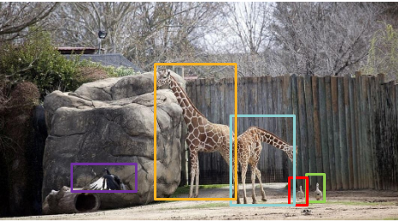
Image Pixabay

- Identify the animal. Classify the animal by its observable features and show this data represented in a suitable format on screen that is visually appealing.

- Also provide further data about the animal in a more detailed view as an option for users if they select more info button.

