# Create a board game that uses an Ozobot

*Please refer to the online lesson plan on the DT Hub to access all website links and additional resources.*

**Year Level: 3-4:** Create a game board where the player is provided with a number of decisions. Using Scratch and Makey Makey, students add multimodal elements to the story. These elements are activated using an [Ozobot](https://ozobot.com/).

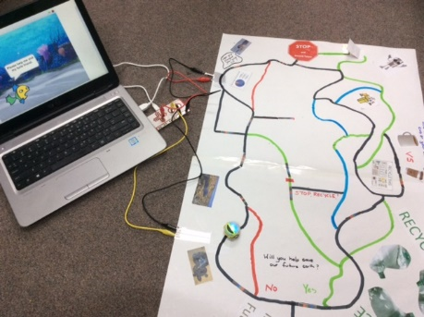

*Photo courtesy of Jo Klein*

# Suggested steps

### Investigate and define

Introduce students to the Ozobot, using the Cloud Ozobot Maze or Space Butterfly Maze (available at ozobot.com). Organise students to draw their own mazes using colour codes and decisions (algorithms).

### Generate and design

1. Discuss how a *‘*choose your own adventure' story works. Explain the concept of this type of story is to allow the reader to choose different pathways leading to alternative events within the plot.
2. Model the construction of a storyboard that will portray graphically the choices and subsequent outcome of each choice as an algorithm with branching. Relate this to how the Ozobot is going to choose different paths within their story/adventure.
3. Students:

* plan out their story using a graphical algorithm model that includes simple branching options
* draw the story on paper to display the plot, including all branching choices offered and alternative endings (if included).
* on the large sheets of paper, connect story paths for the Ozobot to follow by using black and coloured lines. They include intersecting lines to include branching options (by default, at an intersecting line the Ozobot will randomly decide which path to take unless a code is used).

### Produce and implement

Using Scratch (or similar visual block-programming software), students create simple animations for the key plot points or events in their story, using sprites and/or speech/audio blocks.

## Extension

* Include conditionals, branching and user input (eg, imagining that the player is asked which path they want to take).
* Connect the computer to the story mat using a Makey Makey and use a ‘switch’ to activate multimodal elements created within Scratch.   
  **Hint**: To create the circuit, include conductive tape or aluminium foil under the paper switch (see it at the top middle part of the picture).

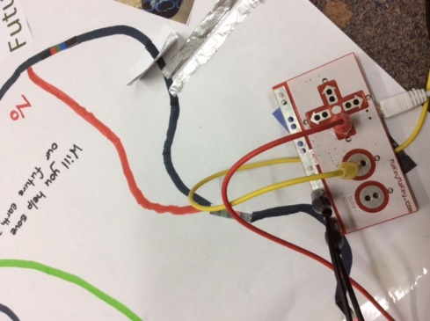

*Photo courtesy of Jo Klein*

Makey Makey activates when the Ozobot proceeds over the paper, completing the circuit. See the aluminium foil at the top of the image.

### Evaluate

Invite students to share their interactive stories with their peers and discuss the alternative endings or variations in endings.

# Discussion

* Students explain how their story meets the audience's needs and how the concept of ‘branching’ or decision making helped the audience make their decision.
* Was enough information provided to help them decide which path to take?
* Was the information confusing at any point?
* Centre the discussion on data and ask students to suggest what data was needed to help readers make their decisions.

# Why is this relevant?

Decisions are important within computational thinking. They allow actions to be changed, based on the input of data. This input could be:

* user-input; for example, selecting an onscreen value or button, typing in an answer
* sensed from the immediate environment; for example, collected via a sensor on a robotic device sensing an obstacle and being programmed to avoid it (or, in the case of Ozobots, different colours when sensed will change the speed).

Algorithms are the step-by-step procedures required for solving a problem. Algorithms may be described either diagrammatically or in structured English. Flowcharts are often a good way of visualising algorithms and can be an effective way to teach the concept of ‘branching’. Branching involves making a decision between one of two or more actions, depending on sets of conditions and the data being inputted.

This activity can be used to strengthen students' understanding of computer programming and robotics. It can be used to combine computer programming and robotics to create engaging and innovative solutions to simple digital problems, using multimodal texts.

To create a STEM-based unit, include:

* construction of a story background, using bridges and 3D elements to add in elements of engineering design
* focus on a science concept, eg create a space game board or design a game with data on ways to create a future Earth.

# Assessment

Evaluate students’ understanding using a simple checklist. For example:

* The storyboard represents a sequence of events that follow a well-defined plot.
* The storyboard provides the reader with a choice of options leading to alternative endings.
* Scratch animation includes branching and user inputs.
* The interactive story is correctly connected to a Makey Makey and includes visual data and information directing the reader to the correct path chosen.

# Australian Curriculum alignment

## Technologies – Digital Technologies

* Define problems with given design criteria and by co-creating user stories (AC9TDI4P01)
* Follow and describe algorithms involving sequencing, comparison operators (branching) and iteration (AC9TDI4P02)
* Implement simple algorithms as visual programs involving control structures and input (AC9TDI4P04)
* Discuss how existing and student solutions satisfy the design criteria and user stories (AC9TDI4P05)

## English

**Creating literature**

* Create and edit imaginative texts, using or adapting language features, characters, settings, plot structures and ideas encountered in literary texts (AC9E3LE05)

**Creating texts**

## Plan, create, edit and publish imaginative, informative and persuasive written and multimodal texts, using visual features, appropriate form and layout, with ideas grouped in simple paragraphs, mostly correct tense, topic-specific vocabulary and correct spelling of most high-frequency and phonetically regular words (AC9E3LY06)

## Create and edit literary texts by developing storylines, characters and settings (AC9E4LE05)

## General Capabilities

Digital Literacy

Managing and operating

* Manage content
* Protect content
* Select and operate tools

Creating and exchanging

* Plan
* Create, communicate and collaborate
* Respect intellectual property.