More than just making: STEM in project-based learning
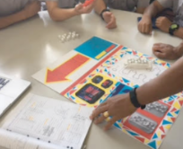
http://www.parramarist.nsw.edu.au/e-news/parramatta-marist-high-e-news/208-2016-11-04.html

How can we ensure that STEM programs increase students’ problem-solving ability and are not just a gut reaction to the worldwide ‘STEM-urgency’?
Kelly Bauer, STEM and Innovation Coordinator, explores the strategies being used at Parramatta Marist High to re-engage students with STEM-based subjects, particularly engineering.
A four-pronged approach to STEM
At Parramatta Marist we have implemented a four-pronged approach to developing STEM. This includes programs developed for:
- increasing students’ learning (knowledge and skills) in these subjects
- developing students’ problem-solving skills in general, by exposing students to subjects where problem-solving is essential
- increasing students’ exposure to STEM-based disciplines, therefore increasing the likelihood of choosing STEM-based careers.
The four aspects of the strategy underway at our school include:
- curriculum
- cross-curriculum
- extracurricular
- community engagement.
The curriculum approach
STEM, underpinned by project-based learning (PBL), encourages inquiry, innovation, and academic rigour within the fields of Mathematics, Science and Technology in order to create a contextual learning environment for students where knowledge is built through projects and problem-solving.
In 2015, Parramatta Marist High implemented the iSTEM Board-endorsed course developed by Maitland Grossman High School.
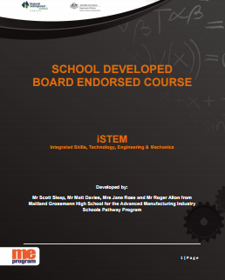
This syllabus is designed to re-engage students with STEM-based subjects, particularly engineering. Its implementation at Parramatta Marist was a huge success, as evidenced by the 2016 round of student selections, where three times the usual number of students selected iSTEM as their first preference.
In 2016, the strategy was expanded to include a 100-hour, core Year 7 course, where students’ study integrated STEM within a PBL pedagogy, modelled on the BOSTES curriculum outcomes for Science, Maths and Technology (Mandatory) course. While this course does not take any time from the core subjects, it is an opportunity to teach those outcomes in a real-world applied methodology.
Year 9 iSTEM: Aerodynamics
The project for Year 9 students focuses on aerodynamics. Students are challenged to solve the authentic problem of ‘How can a drone be used in a natural disaster to save human lives?’
Students were exposed to a range of mathematical, scientific and engineering content, including Bernoulli’s Principle, Newton’s Laws, ratios and distance while building their own drone. This project forced students to analyse the forces of flight and gain an understanding of how flight works and how this is influenced by STEM disciplines.
Year 7 STEM: It’s just rocket science
Year 7 students planned how to drop a bottle rocket at a specific point on the oval. In order to do this, they had to create scale models of the oval, observe differences in results based on different variables, and then experiment with different types of bottle rockets in order to see whether they could drop the package at the correct point. This data was then combined into a video explaining the maths and science behind the bottle rockets. Watch a sample video: It's just rocket science!!!: STEM summative task by 'THE MSN'.
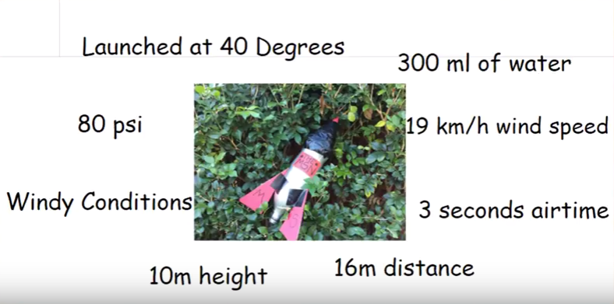
The video Parramatta Marist High STEM bottle rocket project interview captures a little of the students’ experience of this project activity.
Geometry dash
This unit of work begins a structured program, where students from years 7 to 10 participate in curriculum-based coding experiences every year, progressing in difficulty over the year levels. This program includes a focus on iterative problem-solving, where students are encouraged to follow the modified Polya’s problem-solving process.
Students learn to code in Java with the use of the iPad app Tickle in order to program a choice of physical programming tools around a maze based on geometry. Students learn the structures of programming with block-style code, which can be applied to learn other programming languages. To solve the maze, students must measure and calculate different geometrical structures. Ramps are included so students must also look at speeds and calculate gravity to plan and then code where the Sphero will go.
Extracurricular activities
Students have also been given a number of opportunities to engage in extracurricular activities in STEM. This allows more students to engage in STEM-based activities of their choice. There has been a huge amount of interest in these activities with hundreds of students across the five activities. However, we need to remember that competitions are not curriculum and, although useful for the engagement of students, the priority is implementation and improvement of curriculum in order to create long-lasting growth.
- Cuberider: Students in this program study Space, culminating in developing an experiment where students program a Raspberry Pi micro-controller that gets sent into space via a NASA rocket.
- F1 in schools: Students in this program study forces, motion and aerodynamics in order to create a model F1 car, raced using carbon dioxide cylinders, along a 20-metre track.
- Code Club: students study a badge-based differentiated program of study about programming to obtain badges as a reward for study. This culminates in entry to the Australian STEM Video Game Challenge.
- Genius Hour: Based on Google’s concept of 20% time, students are able to spend an hour a week working on anything that they are interested in. This is based on the idea that giving time and resources to student passion will allow students to perform. This culminates in the Young ICT Explorers competition.
- Aurecon Bridge Building: Three students from the intermediate Year 9 Maths class who seem disengaged with Maths, are selected to participate in this competition. The aim of selecting these specific students is to determine whether engagement in practical application in Maths will increase individual engagement with this subject.

Community engagement
Raising awareness and support for STEM within the parent community is important to us. We have therefore looked for opportunities to promote the benefits of STEM curriculum and to connect with adults working in STEM-based careers.
Kids Hack Day
Parramatta Marist has become the Australian connection for Kids Hack Day, a global program to engage students in STEM-based careers. On this day, students will have the opportunity to immerse themselves into emerging STEM technologies such as robotics and programming. Kids Hack Day is a one-day event where children and adults come together to ‘hack’ and make new uses of everyday items and new technologies
Innovation Week
For the past four years, Year 10 students have run Innovation Week, a program where they spend a week out of their normal curriculum working on a ‘passion project’ that meets a design need that they select. In the past, students have created projects ranging from creating new sports to marketing materials, from iPad-watching boxes for their bedrooms to planes, drones and amphibious vehicles. This year, Innovation Week will include a greater STEM focus, matched with a two-day professional learning conference for teachers. Parents will be invited to access the guest speakers as well as attending the exhibition of the students’ work.

Cross-curricula activities
Parramatta Marist has chosen to implement STEM technologies as part of regular subjects. This approach raises awareness of the mainstream use of technologies within the context of their regular subjects. It has led to an increase in the number of students applying to participate in STEM extracurricular activities. Examples include laser cutting of flip books for Religious Education, creation of physical artefacts for History students who were asked to curate a museum exhibition, and creating circuits to test the salinity of water in Geography.
This is the next stage of technology integration, where students use industry level technology to construct physical objects to express their learning.
Key resources
- Spheros
- Tickle app

Useful online resources
- iSTEM NSW Board Of Studies Teaching And Educational Standards (BOSTES): Board-endorsed course – Stage 5
- ME Program: iSTEM
- Polya’s problem-solving techniques
- Introducing PBL
- New Tech Network: PBL method
- shortcomp: ICT integration, library and multimedia
- Building a programming mindset

Tips for other schools wishing to undertake a similar project activity
Problem-solving is an area that is now necessary in all subjects. A focus on working technologically, and thinking mathematically and scientifically is proposed as a method to increase students’ capacity for problem-solving. This, along with the opportunity to explicitly teach problem-solving strategies within a project-based applied STEM model, should see students apply these strategies to other learning areas.
The challenge, however, for STEM programs across the world is to ensure that programs do not simply stop at student engagement in STEM, but challenge students to have a higher purpose than just ‘making’. We need to work towards ensuring that STEM programs increase students’ problem-solving abilities – that the school-based STEM programs are not just a gut reaction to the worldwide ‘STEM-urgency’.

About Parramatta Marist High
Parramatta Marist High is an all-boys Catholic school with a history and tradition spanning over 190 years. In 2008, Parramatta Marist High introduced project-based learning into Year 9 to cater for a new technology-rich modern learning environment. Classrooms were redesigned to cater for this technology-rich environment. See the news article Parramatta Marist High School embraces hi-tech classroom of the future for more details.

