Building teacher capacity in ICT
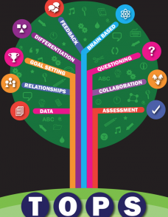
© Oakleigh State School.
Building teacher capacity in ICT
Many schools are grappling with developing the ICT skills of their staff as well as implementing the Digital Technologies curriculum. This article, by Head of Innovation Nicola Flanagan, focuses on the ICT journey undertaken at Oakleigh State School.
In 2010, Oakleigh State School began implementing Curriculum to the Classroom, Queensland’s interpretation of the Australian Curriculum. Many of the units within this curriculum placed quite high demands on teachers in terms of the ICT general capability of the Australian Curriculum.
At that time, Oakleigh State School had a brand new library, built with the Building Education Revolution funding. This building was a perfect example of what can be achieved when a team works together with their minds ﬁrmly on the future. Future-proofed, with numerous network and power outlets, enough wireless access points to cater for large numbers and with a large, open and ﬂexible plan, this library provided a picture of a learning space for the future.
The school’s next step was to welcome a teacher librarian with the versatility, drive and ﬂexibility to support the school in its journey towards the future. Nicola Flanagan provided information literacy support to teachers while also working collaboratively to teach units that had high ICT demands – for example, a Year 4 unit in which Scratch coding was used to engage students with the concept of erosion. This approach enabled the collaborative and non-threatening development of teachers’ ICT capabilities. An experienced teacher partnered with Flanagan to work with junior primary teachers to support traditional literacy and digital literacy practices.
A concurrent initiative, the Smart Classroom strategy, included the ICT Pedagogical Licence framework. This was an opportunity for teachers to develop their ICT skills and to document their learnings to receive accreditation. Teachers at Oakleigh State School were among the last in the state to receive accreditation before the program ended.
SAMR and TPCK
The school used the Substitution, Augmentation, Modification and Redefinition (SAMR) model to support teachers during the ICT Pedagogical Licence process. Find out about the SAMR model at Instructional design/SAMR model/What is the SAMR model? and Connecting teacher and tech using the SAMR model.
In addition to the SAMR model, the Technological, Pedagogical and Content Knowledge (TPCK) model was introduced to teaching staff during professional learning opportunities, including staff meetings, unit planning sessions and year level meeting times.
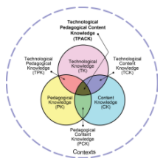
The many sessions enabled teachers to fully understand and integrate their understandings of both SAMR and TPCK.

Publishing in TechWEB
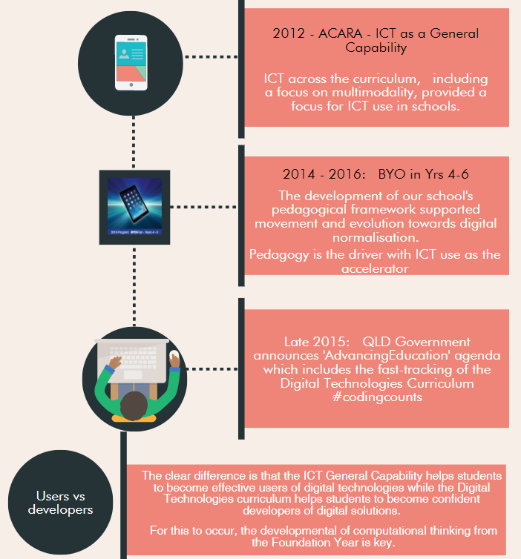
© Oakleigh State School.
In 2011, each school was mandated by Education Queensland to adopt, adapt or create their own pedagogical framework. Oakleigh State School received funding to create a framework through the use of cycles of action research. Signiﬁcant for the purposes of this case study, this funding also enabled the creation of a digital version of the pedagogical framework. iBooks Author, released as a free tool to enable the professional creation of ePubs, was the tool chosen for this process. Each teacher was provided with an iPad to allow for creation of media and to house the completed product.
Throughout this process, ICT was never seen as separate from teaching and learning in our pedagogical framework. It was, instead, viewed as integral to each evidence-based component. Teachers worked hard to share the good work that was going on via the school’s TechWEB blog.
Choosing hardware
After using a range of devices for two years, including shared sets of class iPads, the school researched the value of personal devices and investigated opportunities associated with 1–1 programs for our older students. This process included talking to the community about the potential demands of the future, visiting other schools, talking to staff and asking questions of students. Informative videos of global education experts discussing technology-enabled learning were screened at the P&C meeting. This led to robust conversations about what learning could look like for Oakleigh State School students.
The conversations continued, supported by research into a range of options. See some of the research at Oakleigh State School – Technology – Towards transformation. The school decided to trial a BYO program in one class and held a parent information evening where decisions included the following:
- This would be a trial in one class only.
- The trial would be ‘opt-in’, but classes would be compiled in exactly the same way as they would otherwise be and that this could mean some children would miss out.
- The other two classes would receive similar opportunities, including limited times when they would be allowed to bring their own device also.
- The school would gather data on intended outcomes.
- There would not be a ‘control’ class and no data would be collected on traditional academic outcomes (unethical in the ﬁrst case and too many variables in the second case). The intention was to collect data about how the devices enabled differentiated teaching and learning.
During the trial BYO year, the engaged and committed classroom teacher worked with a partner teacher, the Digital Learning Coordinator, the Head of Curriculum and fellow teachers to experiment with ways that technology enabled learning and differentiation. That group collected data, which was curated into a digital book. They also started a blog detailing qualitative data in the form of stories to document the learning journey. Find examples of this journey at Why BYO? Why 1–1? Why?
Pedagogy placemat
One signiﬁcant piece of work that occurred during this time was a ‘Pedagogy placemat’, a framework that demonstrated the type of tasks that supported aspects of The Oakleigh Pedagogical Standard (TOPS), and how the tasks would be different if they were aligned to different levels of the SAMR framework.
Oakleigh TOPS framework. © Oakleigh State School.
Communications
During this year, the school communicated about this project via many different channels – social media, BYO newsletters, the school newsletter, face-to-face and the TechWEB blog. After exploring the results of the trial year, we offered all years 4 and 5 students the opportunity to bring their own devices. In the following year, there was a 98 per cent take-up of this program over the six classes.
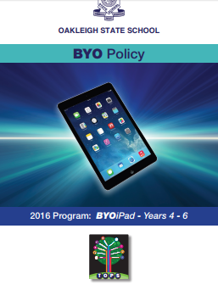
© Oakleigh State School.
The BYO program is now well established and widely respected. iPads are currently the only device allowed. The program is an opportunity for years 4 to 6 students only. It has played a major role in the journey towards digital normalisation at the school.
Key resources and links
- Oakleigh State School: TechWEB
- Oakleigh State School: BYO policy
- Oakleigh State School: Slideshow used at P&C meeting
- Oakleigh State School: Getting started
- Oakleigh State School: Why BYO? Why 1–1? Why?
- Digital technologies: The Oakleigh State School way
- ICT vs digital technologies: Resources illustrating the differences and similarities between ICT and digital technologies
- Writing a letter to the future: Part 2 of the Oakleigh State School digital technologies journey
- North Fitzroy Primary School: Examples of another primary school with significant investment in improving the ICT and digital technologies skills of their community.
About Oakleigh State School
Oakleigh State School is located in the inner west Brisbane suburb of Ashgrove.

