Pixels and binary digits: Pixels handout
Name: |  | Date: | / /

Use the image to explain how a computer uses binary digits to encode an image.
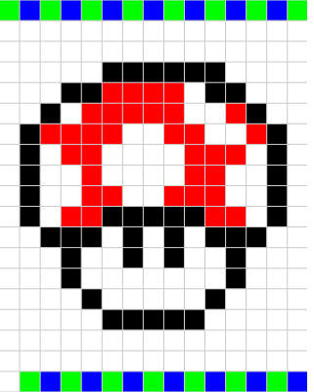
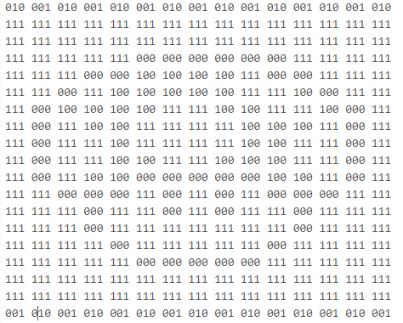
Digital Technologies Hub is brought to you by
Creative Commons BY 4.0 licence unless
otherwise indicated.

Australian Government Department of Education and Training
Page 1 of 2

Pixels and binary digits: Pixels handout

Questions
There are 8 colours able to be made using 3 bit binary digits.
Five colours were used to create the bitmap image.
Write the corresponding 3 bit binary numbers for each colour. White has been completed.
_______
_______
_111___
_______
_______
3 colours were not used.
How would you make these colours using 3 bit binary digits? ______ ______ _______

Create your own image and encode it using 3 bit binary digits.
Digital Technologies Hub is brought to you by
Creative Commons BY 4.0 licence unless
otherwise indicated.

Australian Government Department of Education and Training
Page 2 of 2

