Digital Technologies Hub
Something that has made a difference…

The aim of this project activity is to draw out the activities in schools that are helping school leaders and teachers to implement Digital Technologies curriculum and activities in their schools.
These stories will be published on the Digital Technologies Hub (https://www.digitaltechnologieshub.edu.au/) under the heading “Something that has made a difference…”.
Your job is to try and capture (in words and/or images and/or video and/or curriculum docs) a specific activity or set of activities that has helped to shift the place of digital technologies in your school. You should think about activities which could be emulated by other schools with a little advice (such as this) or additional funding or specific professional learning etc.
You can either write in first or third person. It does not need to be formal in tone. All you need to do is to fill out the template below and return it to Jill Wilson at Education Service Australia (jill.wilson@esa.edu.au, 03 96579773). We will give the words a light edit and check the final copy with you before it is published online.
Our preference is to acknowledge both you/your team and your school but you can be anonymous if you wish.
Photos, samples of student activities and videos will help bring this work to life. If you have any of these items, we will need to gain permission from those students/teachers who are part of the visuals or who have contributed work to the project. We will supply you with permission forms for this project activity if you need them.
The following headings are a guide- if some or all of them are not applicable, please feel free to delete.

TEMPLATE: Something that has made a difference…

My school
(Here a very brief description of relevant context – eg how many students, Primary/Secondary, location, and relevant programs to this project)
Torrens Valley Christian School is an R-12 school located in the North-Eastern Suburbs of Adelaide, South Australia. We currently have around 650 students.
In 2015 the school appointed an eLearning Coordinator for Years 7 to 12 (as well as two for Primary School, 1 for Reception to Year 2 and another for Year 3 to 6). The vision of this role was to improve the eLearning at the school, in regards to infrastructure (working with the IT Manager and IT staff), 1:1 devices, curriculum changes including implementing the Digital Technologies Curriculum and staff development.
Since then the school has seen the introduction of the following:
- An upgrade of the wireless infrastructure
- An upgrade of the 1:1 devices for Senior School - Microsoft Surface tablets for Yr 10 – 12
- 3 laptop trolleys available for Middle School Students (Yr 7 – 9)
- Access to Office 365 and OneDrive and therefore the use of OneNote Classroom Notebooks
- SACE Stage 1 and 2 Information Technology classes
- Implementation of the Digital Technologies Curriculum (R-10)
- Robotics including being involved with the FIRST Lego League competition
- Teaching of Raspberry Pi’s
- Teaching of programming in multiple languages
- Girls Only Code Club
- Robotics Club

What initiative has led to changes in the way that Digital Technologies is implemented in my school?
It would be rare that just one initiative made all the difference but we want to keep it simple. 1-2 key activities are what we are looking for. If you have more than this to write about, I suggest completing another template as well. We will link to it online. In this section, focus on:
- What was the initiative?
- How did it make a difference? Was the biggest impact on students, teachers, the school community, school leaders etc?
- How was it implemented in your school? What factors were critical to its success?
- Are there ways that you wish to build on this initiative in future?

Initiative 2: Introduction of Robotics EV3s and Raspberry Pi’s at Year 9 which led to being involved in the FFL Competition and the creation of the Robotics Club
In 2016 the school purchased 10 Lego Mindstorm EV3 kits which we use with the Year 9 Computing classes. The students learn the fundamentals of programming, loops, conditions etc while programming a robot which they design and create.
We found this was an easy introduction to computational thinking and programming for students who would normally struggle with actual code and writing procedures.
The engagement level of the students was almost 100% every lesson. Students work in groups or 2-3 depending on the class size.
This then led to us entering a team into the FIRST Lego League competition where students had a ball learning new skills and meeting students from other schools.
We now have a Robotics Club that runs all year where students review the performance of the robot from last year to learn from their mistakes and challenges to improve for the coming year.
Last year we had 3 Yr 9 Computing classes (1 in Semester 1 and 2 in Semester 2). The class sizes were around 20. This year we have 2 classes in Semester 1 with 21 students in one class and 28 in the other. Because of this extra large class we decided to purchase some Raspberry Pi’s and rotate the students in 3 groups in the Semester so they all got to try the EV3s, Raspberry Pi’s and Flash Animation which is the other topic at Year 9.
The students have loved programming the Raspberry Pi’s, in particular, using the Sensor Hats which we also purchased. If the school had not allowed us to introduce these we would potentially have had some behavior problems as our groups within the classes would have been too large and not all students would have been able to actively participate in the class activities.
The Raspberry Pi’s are quite easy to set up and there are simple tutorials that can be run with the students. The same was the case with the EV3s, as students could follow the tutorials provided by the Mindstorm software.
This allowed the teacher the freedom to move around the class and assist students in whatever task they were working on, whether that be the Raspberry Pi’s, EV3s or Flash Animation.
UNIT OVERVIEW Yr 9
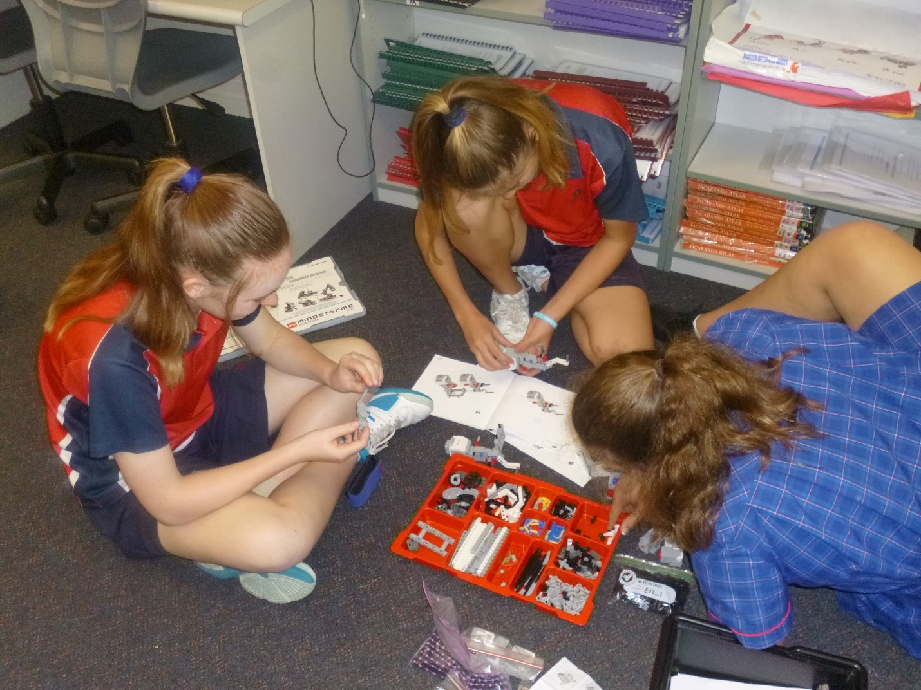
Students building their first EV3 robot.
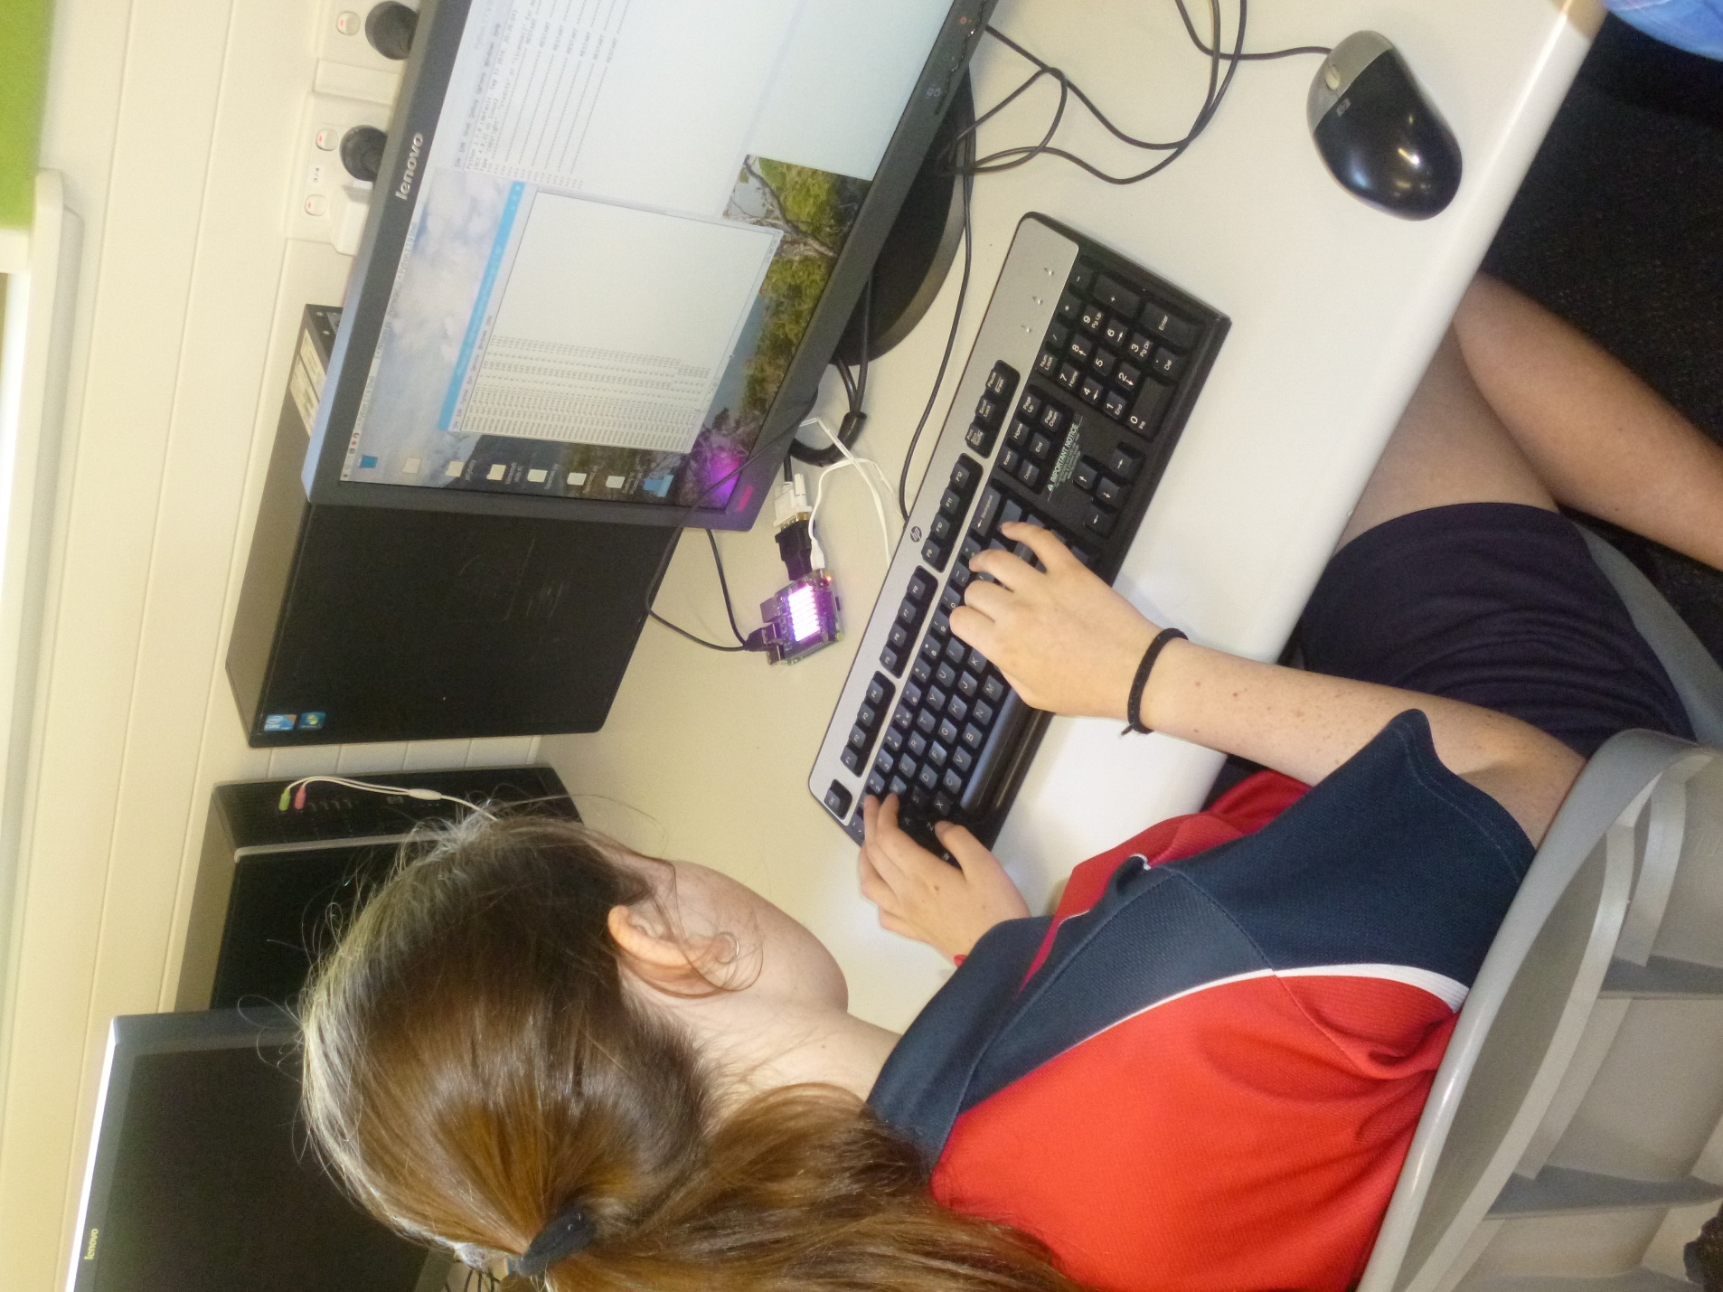
Raspberry Pi with Sensor Hat
What resources were required to implement the project activity?
Here, it might include funding, timetabling, provision of equipment, professional learning etc. If you can be specific about the resources that were useful, that would be great.
Resources:
- 10 Lego Mindstorm EV3 kits plus Expansion Kit
- 15 Raspberry Pi’s with 8 Sensor Hats

Did you use any online resources/links that other schools might find useful?
- https://www.raspberrypi.org/resources/
- https://www.lego.com/en-us/mindstorms/learn-to-program
What advice would you give anyone wishing to undertake a similar project activity?
While the set-up costs may be high, the benefits to the student learning and engagement are priceless. It is important to keep the groups as small as possible. 2 per group is ideal but 3 can work as well depending on the individual students.

Anything else?

