Name _________________________________________ Date ____/_____/____
Project

Algorithm written in pseudocode

I can (circle the skills you have demonstrated or write in any other skills)
Run a test for random numbers
- check the output

Create a prompt
- user enters heads or tails

Use a string
- prompt text
-response to user input

Create a random number
- 0 or 1

Use if/ else statements
- two options depending on user input for heads or tails

Declare and assign a variable
- variable for user input: heads or tails

Digital Technologies Hub is brought to you by
Creative Commons BY 4.0 licence unless
otherwise indicated.

Australian Government Department of Education and Training
Page 1 of 3

A screen capture of my code and what displays onscreen selecting ‘Run’

Read the following rubric.
Circle the description that best describes your programming on this project.
1 point | 2 points | 3 points | 4 points
I created the program but needed a lot of guidance and help from others.  I have learned up to 2 new programming skills and identified these skills using the ‘I can’ statements. | I created the program with a little help from others.  I have learned up to 3 new programming skills and identified these skills using the ‘I can’ statements. | I created my own program following suggested steps. When I got stuck I sought help.  I have described clearly the challenges I had and how I overcame them.  I have learned up to 5 new programming skills and identified these skills using the ‘I can’ statements. | I created my own program. When I got stuck I sought help. I also helped others when they got stuck.  I have described clearly any challenges I had and how I overcame them.  I have learned or used more than 5 programming skills and identified these skills using the ‘I can’ statements.
What three things have learned about programming with JavaScript?
Digital Technologies Hub is brought to you by
Creative Commons BY 4.0 licence unless
otherwise indicated.

Australian Government Department of Education and Training
Page 2 of 3

Scratch program
A guessing game built in Scratch.
For the Scratch project and code refer to Head or tails?
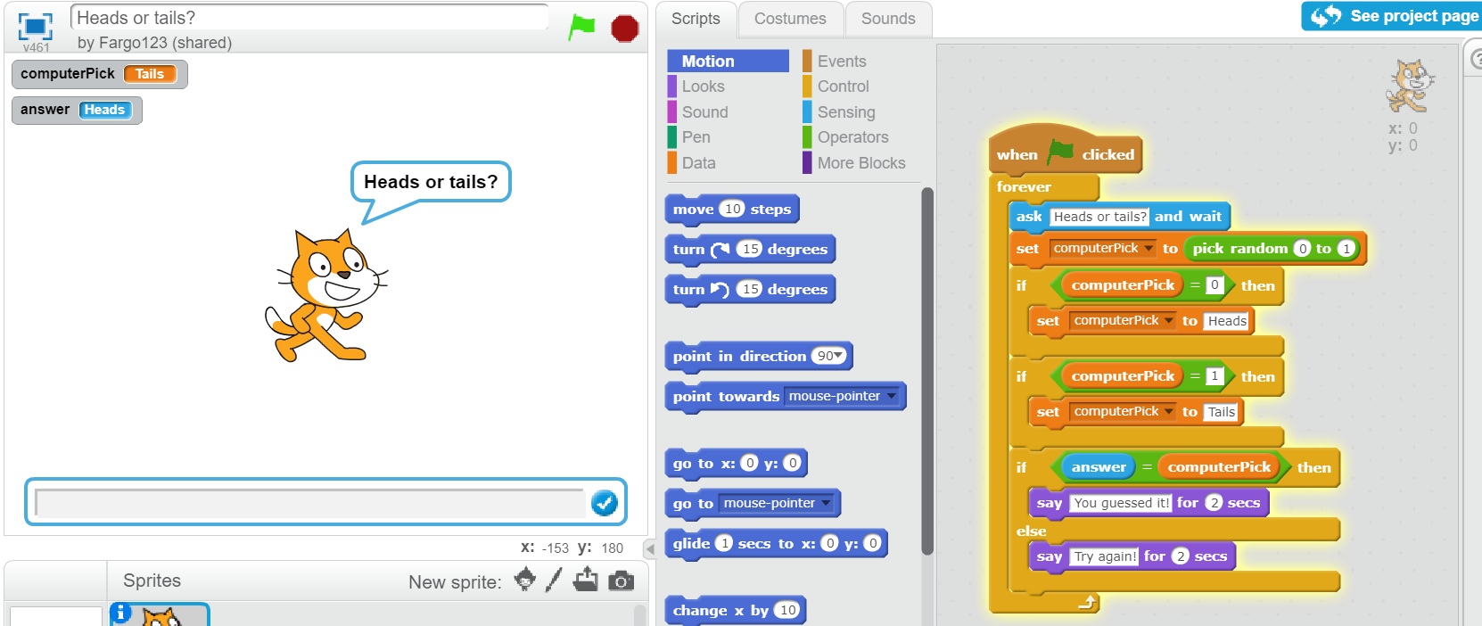
Digital Technologies Hub is brought to you by
Creative Commons BY 4.0 licence unless
otherwise indicated.

Australian Government Department of Education and Training
Page 3 of 3
Digital Technologies Hub is brought to you by
Creative Commons BY 4.0 licence unless
otherwise indicated.

Australian Government Department of Education and Training
Page 3 of 3

