Instructions  Review the user story and key functions you selected or created.  Based on the user story, brainstorm and complete the following sections to create your own design criteria.  Use the empty template for your user story and fill in the design criteria.  Here’s an example to help you.  User story  [Include the user story here.]  Example: Keisha is an adventure enthusiast who loves to explore the great outdoors. Keisha wants to ensure she knows her location, even without mobile reception, and wants to document her trip with photos, notes and locations. That way she will not get lost, and have a journal of her trip.  Key functions  [Include the key functions here.]  Example: GPS navigation: The app should provide accurate GPS navigation to help Keisha find her way on the trails. Offline mode: An offline mode is essential, so Keisha can use the app in areas without mobile reception. Photo journal: This should allow Keisha to take photos, add notes and mark significant locations on the map. | 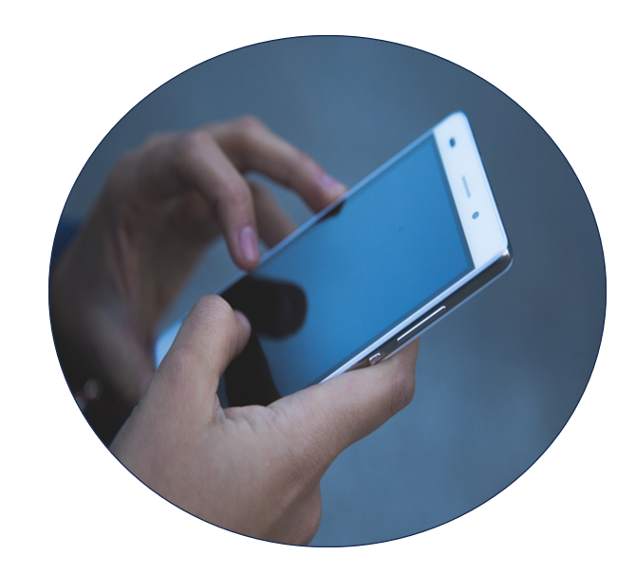

Prompt questions | Design criteria  (example) | Have you achieved this in your app design? ✅
User needs and goals  What are the specific needs and goals of the user in the story?  What problem or challenge is the user facing that the app should solve? | - The app should prioritise safety and user confidence by offering reliable GPS navigation in remote areas.  - It should also provide a seamless photo journal feature to capture Keisha’s journey.
Functionality and features  List the features and functions the app should have to meet the user’s needs.  Explain how each feature or function addresses the user’s requirements. | - The app must offer real-time GPS tracking with detailed maps, trail information and the ability to set coordinates. This will help the user avoid getting lost.  - The photo journal feature should allow for easy photo capture, note-taking and the option to tag locations on the map. This will help the user document her journey.
User experience (UX)  Describe the desired user experience. How should the user feel when using the app?  What design elements or interactions will enhance the user’s experience?  What intuitive navigation elements can be included? | - The app’s user experience should instil a sense of adventure and confidence.  - Users should feel excited and well-prepared for their outdoor experiences.  - It must be intuitive, with clear icons and map visuals for smooth navigation.
User interface (UI)  Describe the visual style and design elements that should be included in the app.  How can the visual design enhance the user’s engagement with the app? | - The app’s visual design should evoke the beauty of the outdoors, with a natural colour palette and outdoor-themed graphics.  - It must have a user-friendly interface that includes large, easy-to-click buttons.  - It must have legible fonts for convenience during outdoor activities.
Accessibility and inclusivity  Consider how the app can be accessible to a diverse audience, including those with disabilities.  What measures can be taken to ensure inclusivity? | - The app should prioritise inclusivity by providing voice-guided navigation to assist users with visual impairments.  - Efforts will be made to ensure that all text and content are available in multiple languages to cater to users from diverse backgrounds.

User story
[Include the user story here.]

Key functions
[Include the key functions here.]

Prompt questions | Design criteria | Have you achieved this in your app design? ✅
User needs and goals
What are the specific needs and goals of the user in the story?
What problem or challenge is the user facing that the app should solve?
Functionality and features
List the features and functions the app should have to meet the user’s needs.
Explain how each feature or function addresses the user’s requirements.

User experience (UX)
Describe the desired user experience. How should the user feel when using the app?
What design elements or interactions will enhance the user’s experience?
What intuitive navigation elements can be included?

User interface (UI)
Describe the visual style and design elements that should be included in the app.
How can the visual design enhance the user’s engagement with the app?

Accessibility and inclusivity
Consider how the app can be accessible to a diverse audience, including those with disabilities.
What measures can be taken to ensure inclusivity?

