What’s the buzz?

Year level band: Foundation - 2
Description: In this lesson students use BeeBots and Scratch Junior to synthesize what they know about Bees and are introduced to mapping concepts.
Resources:
- BeeBots - 6
- 15cm X 15 cm cardboard squares
- Paper
- Large A2 paper or Magic Whiteboard
- Markers
Prior Student Learning: Students could have been immersed in a scientific exploration of bees, asking questions and discovering more about the wonderful world of bees.

Digital Technologies Summary
This learning sequence allows students to explore how BeeBot robots work. Using the buttons students can identify a simple user interface and how it works. The BeeBots themselves represent hardware that the students are exploring. By controlling the bees through the buttons and recording the process students are following and describing simple sequences of steps.
They also synthesize the information they have discovered about bees to create a map for the bees to follow in order to get from the hive to the flowers with the high quality pollen.
Creating a map based upon their knowledge involves representing data as pictures, symbols and diagrams, linking to geography.
Videos of the BeeBots moving along the map could be shared in an online space for others to productively critique.
Year | Content Descriptors
F-2 Digital technologies | Recognise and explore digital systems (hardware and software) for a purpose (AC9TDIFK01) .  Identify and explore digital systems and their components for a purpose (AC9TDI2K01) .  Represent data as objects, pictures and symbols (AC9TDIFK02) .  Represent data as pictures, symbols, numbers and words (AC9TDI2K02) .  Follow and describe algorithms involving a sequence of steps, branching (decisions) and iteration (repetition) (AC9TDI2P02) .
F-2 Geography | F: The representation of the location of places and their features on simple maps and models (ACHASSK014)  1: Activities in the local place and reasons for their location (ACHASSK033)  2: The idea that places are parts of Earth’s surface that have been named by people, and how places can be defined at a variety of scales
Achievement Standards | Foundation - 2 Digital technologies  By the end of Year 2, students identify how common digital systems (hardware and software) are used to meet specific purposes. They use digital systems to represent simple patterns in data in different ways.  Students design solutions to simple problems using a sequence of steps and decisions. They collect familiar data and display them to convey meaning. They create and organise ideas and information using information systems, and share information in safe online environments.  Geography  F: They describe the features of familiar places and recognise that places can be represented on maps and models.  1: They recognise that people describe the features of places differently and describe how places can be cared for.  2: They recognise that the world is divided into geographic divisions and that places can be described at different scales.

Element | Summary of tasks
Learning hook | Explore before Explain  Show a picture of a bee and ask the students to consider what they remember about bees. Introduce a different kind of bee. Show the BeeBots. Get students to play with them in groups and ask what they notice about them.  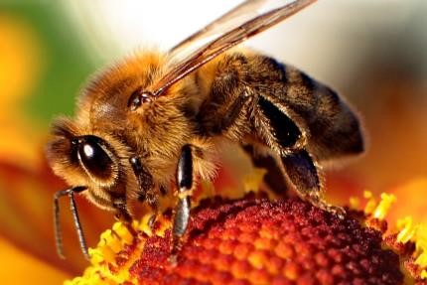
Learning Map  (Sequence) | Explain the term “algorithm” as a sequence of steps. Ask when else they have to follow steps e.g. a recipe, teacher instructions, Lego instructions, etc. Explain that they are going to be creating a sequence of steps and a map for their BeeBot in order to learn about “algorithms”  Discuss the way maps are representative. In this case the map and the bee are not to scale. However the 15 x 15 grid used can be compared to other gridded maps. But the places that are important for bees can be discussed (the hive and the flower) and the hazards to bee populations.
Learning input | Brainstorm what the group knows about maps. Explain that they are going to create a map for their BeeBot. The map must show a hive and a flower at opposite ends. In between the bee needs to avoid hazards.  Model a map on the board using symbols for water and hazards that the children describe. Children can then bring in what they know about predators and threats to bee life. The children can create the maps and the bee path in groups.  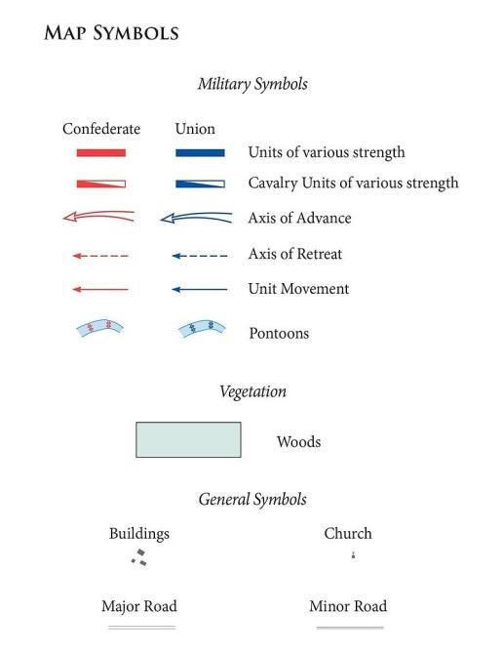  Image by United States Army Center of Military History. - Wineman, Bradford Alexander. The Chancellorsville Campaign, January-May 1863. Washington, DC: United States Army Center of Military History, 2013. OCLC: 847739804. Source: [1], Public Domain, https://commons.wikimedia.org/w/index.php?curid=48576167
Learning construction | Allow Learners to program the bee bot to move to each person in a group. Groups could be formed from 3-6 depending on the number of BeeBots. They will probably work out they need to clear the instructions to get the BeeBot to move to a different person in the group after they receive the BeeBot.  Draw attention to the fact that they only move a certain distance, that the BeeBot responds to the buttons, and that they remember the sequences previously programmed. Ask students to think about how they work. Introduce the term “user interface” to describe the buttons.  You may want to assign group roles so that students share the task fairly. Group roles could include:  - Cartographer (map designer)  - Programmer (writes the sequence of steps)  - Documentary Maker (someone who films and documents the process)  - Director (someone who organises all the materials, collects and returns them)  - Reporter (someone who explains the learning to the bigger group during reflection)  - Explainer (someone who stays with the map to explain to a new group the  “code” to get the BeeBot from hive to flower)  Learners create a floor map for the BeeBot on large paper. The Cartographer can collaboratively design the map first on paper and then the whole group can draw sections of it. Many children will decide to grid the paper out first with the 15x15 squares. Those that don’t will discover that it is very difficult to create a path and for the BeeBot to avoid hazards if they don’t plan it out. This is good learning.  The Programmer can record the final sequence of steps using whatever symbols they choose. Some will choose arrows and symbols, others will use text.  If learners become frustrated or hit the “learning pit”, it would be a good time to gather them together and demonstrate how important it is to grid out the map and have symbols contained within 15x15 squares. They can do this by tracing around the cardboard square you gave them.
Learning demo | After the maps are complete and the learners are happy with the steps they came up with, get them to number off.  The Explainer stays with the map and the rest of the groups rotate around the other maps and see if they can follow the sequence of steps devised by another group. This helps children understand debugging.  They will discover if the the instructions work or not, or if they are clear to them.
Learning reflection | Bring the group together and ask them what they noticed about each other's maps. Talk about the different ways each group recorded the steps. Discuss how important it is to have a standard “code” or language for their algorithm to describe the steps so that everyone can understand how to program the BeeBot. This introduces the term code. Students could also write a reflection using the sheet provided below in the teacher instructions wand which is also available in (Bee Blendspace)

Assessment:
A reflection sheet is attached and also available here (Bee Blendspace)

 | Quantity of knowledge |  |  | Quality of understanding
Criteria | Pre-structural | Uni-structural | Multi-structural | Relational | Extended abstract
Map | Map is a picture and shows no structure or symbols and is not easily navigated | Map has been gridded and shows simple symbols | Map has been gridded and shows a complex path that can be navigated only by following a recorded programme. | The map  symbols link to the student’s understanding of bees and how the BeeBot moves | The map symbols link to the student’s understanding of bees and how the BeeBot moves in 15 cm bursts and is linked accurately to the programme
Bee Program | No steps have been recorded | Simple steps have been recorded but do not correspond with the map or do not get the bee from the hive to the flower | A complex sequence of steps has been recorded and matches the  path to the map | The programme uses a an inconsistent set of symbols and directions that may or may not work with the BeeBot | The programme that is recorded uses a consistent set of symbols that anyone can use and decipher to accurately move the BeeBot through the map.
Vocabulary | When  describing the BeeBot path and the map no specific vocabulary is used | When  describing the BeeBot path and the map terms steps, instruction  or pictures and gestures may be used as a general description | When  describing the BeeBot path and the map the terms algorithm and directional language is used as a general description | The terms algorithm is used confidently with specific reference to learner’s work. Learners also confidently use mapping terms | Specific vocabulary like decisions and repetition is used, going beyond the set language.

Teacher/Student Instructions:
An alternative to using a rubric to assess students at the end could be to use a single point rubric that is explained to the students throughout the process. An example is below. Download the teacher/ student instructions here.
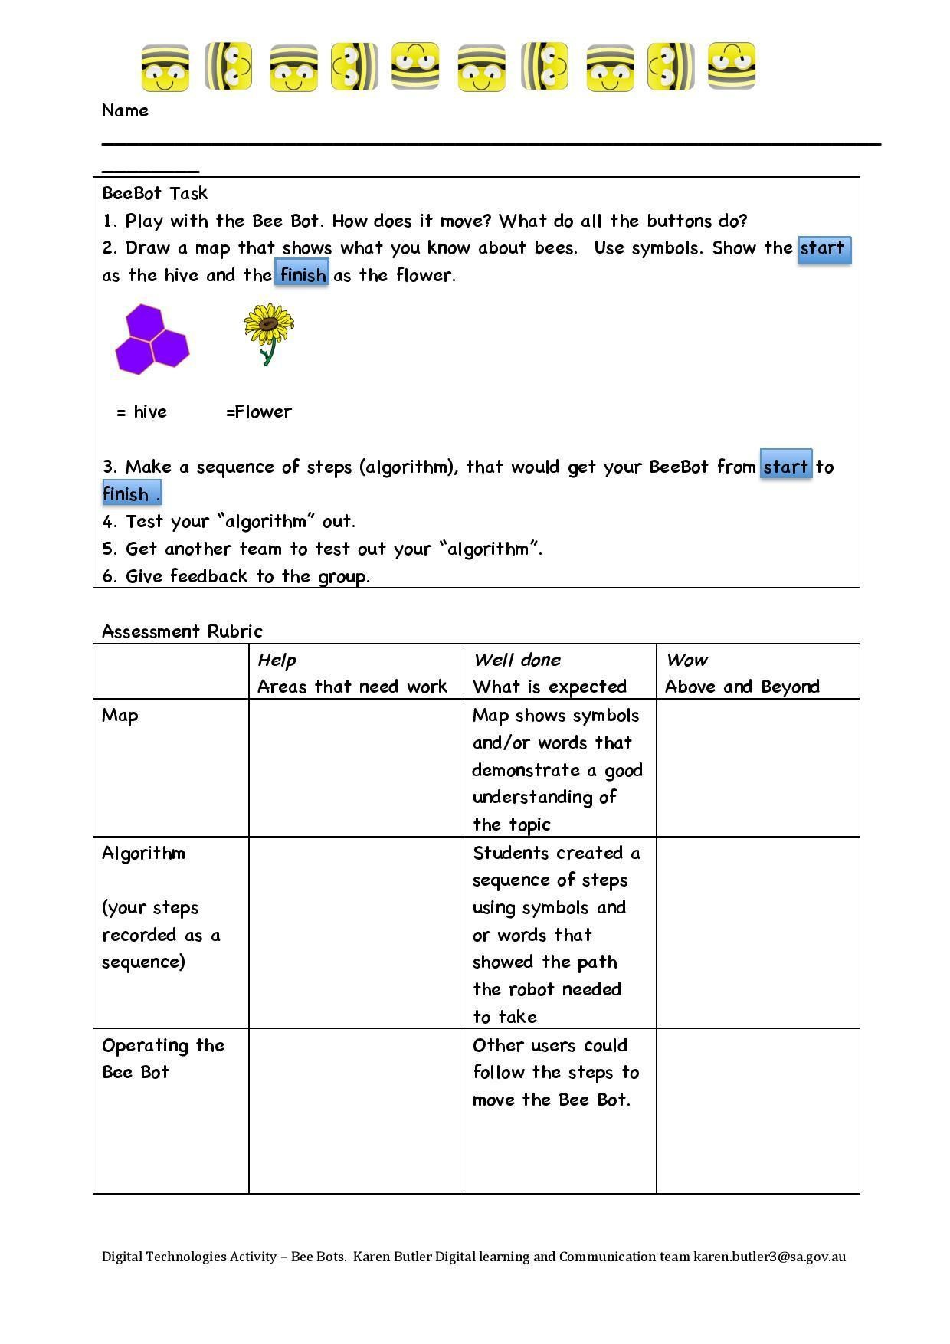
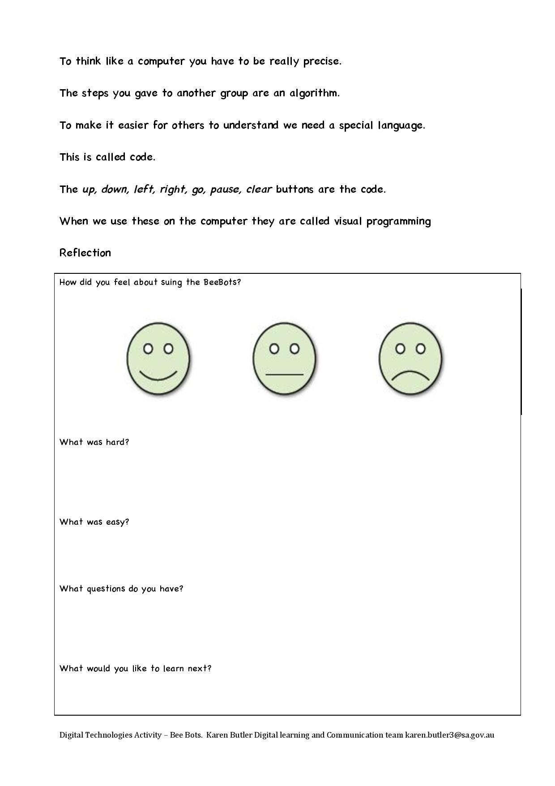

CSER Professional Learning:
This lesson plan corresponds to professional learning in the following CSER Digital Technologies MOOCs:
F-6 Digital Technologies: Foundations
- Unit 5 Data representation
- Unit 7: Algorithms and Programming
- Unit 8: Visual Programming

Further Resources:
For resources on bees and how to conduct an inquiry into bees go here Bee Blendspace: https://www.tes.com/lessons/cBMcfsjX85TUiw/what-s-the-buzz
Digital Technologies Hub: https://www.digitaltechnologieshub.edu.au/
CSER: https://csermoocs.adelaide.edu.au

Author: Karen Butler.
This work is licensed under a Creative Commons Attribution-NonCommercial 4.0
International License. Computer Science Education Research (CSER) Group, The University of Adelaide.

