GAFE and the Australian Digital Technologies Curriculum
A Google Apps for Education Webinar with Rebecca Vivian & Chris Harte
These notes support our online webinar which can be viewed here: https://www.youtube.com/watch?v=DcKX3jLw1SU
These resources cover:
- Data visualisation
- Designing algorithms
- Collaboration and communication
However, for the full range of ideas and demonstrations, please refer to our webinar and the “notes” in the webinar for further links.

Data visualisation
This aspect of the Digital Technologies learning area is important for a number of reasons. Data visualisation encourages students to build skills in collecting, analysing and representing data.

Why is this important?
Digital Technologies is not always about developing solutions in code. Computer Science and Digital Solutions also involves about learning how to harness real data to create solutions. Finding creative ways to collect and represent data to produce meaningful information is a vital skill, transferrable across any profession today. Further, collecting data and researching the context for which you are solving a problem for, can be just as important as creating the solution!

GAFE + Surveys = Google Forms
Surveys can be simple yet powerful in terms of collecting data that can solve problems. A real example is Erica Kochi Co-founded and co-leads UNICEF's Innovation, Unit. They needed to find a scalable way to register births and identify people in need of health treatment. In coming up with their solution, they had to research and understand their context. In their initial research, they found that most people in remote locations, Eastern Senegal, had access to a mobile phone. Their digital solution involved creating simple surveys, accessible via mobile phones, to survey people in developing countries about births, health status and medical history, and even environmental conditions. This information helped inform them about strategies and intervention design. This is a simple, yet powerful solution.
Hear about Erica’s story here, via Made With Code: https://www.youtube.com/watch?v=w6071faJFuI

Google Forms and Google Sheets
Google forms is a fantastic way for students to build free online surveys. We use Google forms all the time in our own research here at university. Access Google Forms via your Google Drive.
Students can collect their own data or, students can work with existing datasets, to export into Google sheets. Some data examples include:
- Bureau of Meteorology weather data
- Worldometers.info
- Australian Bureau of Statistics
- Sensor data -e.g. Emil Zankov, teacher at Pedare: https://www.youtube.com/watch?v=F-yTaEiN6gQ
Students can collect data via a survey they create. They can visualise the data and create charts in Google Sheets and then draw on their research findings to create an infographic in Google Slides. See our example here. To get started and create your Infographic poster, customize the width and height of the slide via page setup.
This information could also form an important part to a major project, during their research phase, which informs the solution they will create and can be used to influence the audience as to why this is an important issue (e.g. in their pitch!). .

GAFE + GeoMapping = Google My Maps
A real-world example of a simple, yet powerful solutions using Geo-Mapping, is from the Google Australia team who used their existing product - Google Maps and a new enhanced idea - of mapping environmental disaster alerts, to help Australians identify natural disasters in their region. This resulted in Google Crisis Maps and Public Alerts.
https://google.org/crisismap/australia
http://google.org/crisisresponse/about/publicalerts/
Video: https://www.youtube.com/watch?v=vgYzmsH0efc
Students can collect information and add them as pins on a Google MyMap (www.google.com/mymaps).
Google My Maps allows you to change views (map view, terrain). Students could add data to their map that they investigate or collect themselves or through an existing data set (imported). This geomapping activity could be situated within a school or a neighbourhood, nationally or globally.
The Google My Maps allows users to add a pin to the map and within that include:
- Text (e.g. description, information)
- To add photos or videos to the pin - from their own library or the Internet
- To change the look of the icon
- To add layers
https://www.youtube.com/watch?v=9VZr10afS14 (example video)
Example from our CSER F-6 MOOC:
“Mapping earthquake data and information (videos, websites, images) and integrating them on Google Maps”, shared by Suzie Feodoroff, teacher (see images below).
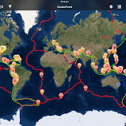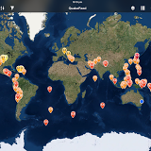
Further, Google Street Views, provides a powerful platform for student projects. It could be used by students to immerse themselves within a particular environment, to collect data about their observations, or as a tool to show classmates or the audience the environment for which they are creating their solution.
https://www.google.com/maps/streetview/
Students could map data about animals they observe, key places of interest, locations that they investigate or more. There are all sorts of problems students could solve, it could be to create a solutions to a new problem, for example:
- Identifying safe bicycle routes for cyclists
- Identifying lost animal sightings
- Identifying sea level changes and impact on communities
- Planning a native garden design for their school or local community
- Or areas in the schoolyard or community that are need in redevelopment
Or some other problem that the students want to solve - that they’re passionate about!
Tip: simply add members using their gmail addresses to a MyMaps project and multiple users can edit the map. This can be shared out using the URL as well (if having it assessed, or wanting an audience to view it).

Algorithm Design
Algorithms are essentially a set of instructions for the computer to follow. These are some fun activities that we use in teacher and student workshops to introduce algorithms and to help participants think about what algorithms are and how to design algorithms.

Google Slides - brainstorming.
Google slides are a great tool to encourage rapid brainstorming or idea generation as a warm-up or during a planning phase.
Rather than getting the audience to call out ideas, ask them to brainstorm in small groups and then contribute their ideas to a slide - either by adding text or images of their ideas. This is a great way to encourage participation and to create a visual product of all the ideas collected. If the audience don’t have access to technology, invite them to come up and add their ideas onto the main computer, go around and chat to them and add their ideas during discussion time. If working with younger students, invite them to share back their ideas and work together to select the correct image.
This slide then becomes a resource that you can refer back to, reflect on (perhaps after the lesson to see how ideas have changed) or can be used to spur on some further lesson idea.
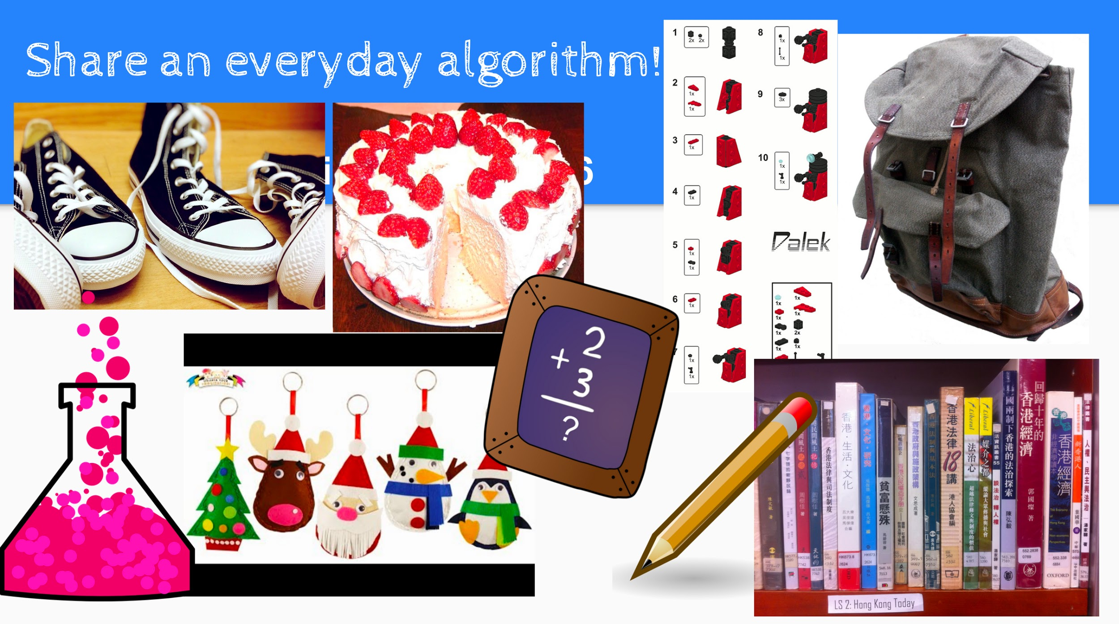
(example of teacher ideas from a workshop)
Some activities that can be used with this approach for Digital Technologies:
- Share an everyday algorithm
- What technology have you used today?
- What technology represents “output devices”/ “input devices”?
- Research and share technology used in other professions, such as medicine, art, science..
- Find images of old technology, or share an image of a specific old technology, e.g. a mobile phone.
This method could also be used by students working in teams or individually, who are generating ideas for a solution for a Digital Technologies project. They can generate a whole slide full of potential ideas and inspiration, and use this to select an idea to explore.
TIP: URL shortener is your friend! Show how to share the slide and enable editing of participants. Using URL shortener: https://goo.gl/

Collaborative algorithm planning
In Digital Technologies, it’s not always about the product: “the code or the program at the end”. Developing students’ skills in designing algorithms and designing solutions is crucial to ensure what they are designing works and to ensure they are keeping track of their design to be able to easily identify better ways of designing solutions or to identify bugs. In university, learning how to create and produce designs is a key part of a Computer Science student experience!
Use Google slides to get students to collaborate on their algorithm design. You might set a task, such as “write instructions that instruct another group how to brush their teeth”. Or “write instructions on how to create a triangle”.
A follow-up activity could be to blend “unplugged” collaborative algorithm writing with digital algorithms - using code!
Students could find a simple shape they would like to create. On a new slide, they work together to create the pseudo code (text instructions) or flowchart for creating that shape. These instructions could be shared with another pair who have to follow the instructions using software such as Blockly’s Turtle Game. If it’s not working, they have to swap back and debug! This is an excellent way to also build students’ code literacy.
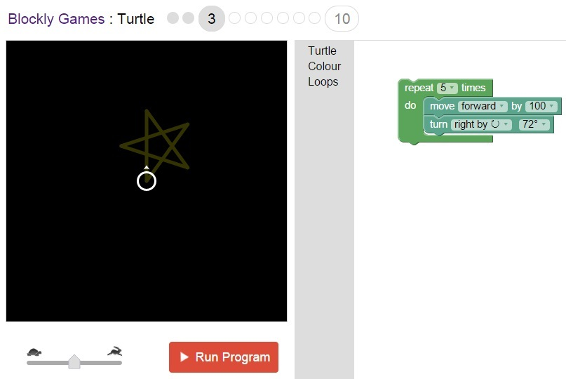
Google’s Blockly Games: Turtle: https://blockly-games.appspot.com/turtle
Flowcharts can be used to create algorithms. We can do this using the “Draw” feature in Google Slides or Docs, or simply by adding text, shapes or images to a Google Slide!
Here’s an example of a teacher, Chantelle, implementing a lesson on using Flowchart algorithms in Google Slide/Docs Draw: https://chantellemorrison.wordpress.com/2016/03/11/algorithmic-thinking-literacy/

Communication & Collaboration
Being able to communicate and work in teams, and especially across remote or distributed locations is extremely important. Computer Scientists, or people working on digital solutions, are often working in teams and with people who could be from anywhere in a country - or even across the world. Building students’ skills in communication and collaboration, and guiding them to use tools in creative ways is really important, regardless of what career they choose!.

Communicating ideas/ Pitching
There are fantastic opportunities for integrating “English” with Digital technologies.
Okay, so they’ve created a game or a digital story in Scratch or another visual programming environment. How can they present their idea to their audience?
As part of their projects, students can produce supporting texts for their games or stories through a portfolio. E.g. marketing materials, covers, blurbs, and advertisements.
The great thing about having students create their texts and supporting documents in Google slides or Docs, means that:
- They can collaborate in real time - students can work on their own devices and add content or work on different parts of the project.
- Students (or you) can come in and provide feedback through commenting
- You can see the revision history, which means you can see who is contributing and when and how the product evolves.
- They can share Slides or Docs with peers or you, and use them to present their ideas to the class.

Sharing online
Being able to share ideas and projects online with others can give students a sense of pride and a goal for their project. Below we have some ideas for encouraging students to share their work online.

Public: Google Hangout on air
Invite other classes, families or other schools to watch students pitch their ideas online.
Australian Google Certified Innovator, Anthony Speranza, has his class undertake a Genius Hour project and presentation online. In this live presentation, students pitched their projects and also responded to any questions coming in from a live audience. They were able to also collect feedback provided by viewers as comments and chat comments. For more information about Anthony’s story, we urge you to look at his blog: http://stmarks56.global2.vic.edu.au/2015/12/02/our-genius-hour-expo-and-google-hangout-term-4-2015/

Private: Google Hangout
Another option could be to have a private Google Hangout and just invite selected people. An example could be where students pitch their ideas to industry members.
This fantastic example conducted through the CSIRO Scientists in Schools Program between a Telstra employee and Eastwood Public School, involves students pitching back their creations for what could be the “communication device of the future” to an industry staff member.
This kind of activity could easily be done online through a Hangout, facilitating convenient engagement between students and industry partners: http://www.scientistsinschools.edu.au/showcase/slaviero-karunaratne.htm

Engage with experts or go on an excursion
Hangouts can also be used by schools to support other uses, such as connecting students or a class with ICT industry experts to ask them questions, to connect with people who are working in professions who use technology in innovative ways to learn about careers, such as those in medicine, robotics, university research and more.
Imagine being able to take your class on a virtual excursion to learn about how underwater robotics are being used to observe marine animals, or to connect with someone who is using 3D printing technology to create prosthetic limbs, or connecting with someone who uses drones to help with farm life or to help wildlife conservation… ?
In this kind of interaction, students could undertake research and pre-prepare questions to ask the expert or “tour guide”. They could also follow up with communication to share projects back to the expert or to ask follow-up questions.
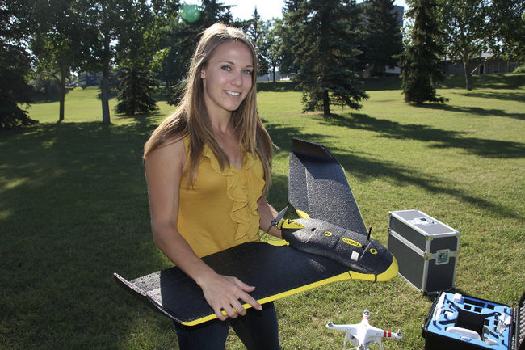
Image: http://www.dailyheraldtribune.com/2014/07/29/new-company-using-drone-tech
Ellie Christopherson has set up a company that uses drones to monitor crop health.
As a teacher, you could setup your own excursions by researching and connecting with potential people, or by also having a look through existing Google+ communities dedicated to connecting classrooms through Google Hangout experiences.
An example community: https://plus.google.com/communities/100662407427957932931/stream/1af408a0-3418-4b1e-a5b2-31c0ddc60976

Additional Resources
Access the Computational Thinking for Educators course at https://computationalthinkingcourse.withgoogle.com
Inside Google’s Design Lab - 360 immersive https://www.youtube.com/watch?v=U2MCAEotzm4
Alice Keeler: http://alicekeeler.com/2013/04/21/have-students-create-infographics-using-google-draw/
Kathy Schrock’s Infographics guide: http://www.schrockguide.net/infographics-as-an-assessment.html
Simple get-started video guide in slides: https://www.youtube.com/watch?v=rNXZJ-QmtA4
https://csfirst.withgoogle.com/materials
Google Apps for Education: https://plus.google.com/u/0/communities/101802680117484972712
F-6 Digital Technologies MOOC: https://plus.google.com/u/0/communities/107555676993339882001
AU/NZ CS Teachers: https://plus.google.com/u/0/communities/117392357338622599346
www.google.com.au/startwithcode
The CSER Digital Technologies MOOCs: http://csermoocs.adelaide.edu.au/

Your links (from the webinar)
http://www.abs.gov.au/AUSSTATS/abs@.nsf/DetailsPage/3105.0.65.0012014?OpenDocument

Thank You!
Thank you for watching our webinar! For more information and additional ideas, please watch the recorded webinar here: https://www.youtube.com/watch?v=DcKX3jLw1SU
rebecca.vivian@adelaide.edu.au @RebeccaVivian
chris@uldtraining.com @charte

