Digital Literacy Schools Grants (DLSG) Case Study:

Taminmin College, Northern Territory

DLSG Round 1 Grant amount: $50,000

School Profile
Glenallen School, located in Glen Waverly, Victoria, provides learning programs for students who have a physical disability and complex medical needs. 78 per cent of students use augmentative and alternative communication. The school offers a comprehensive curriculum aimed at developing each student’s intellectual, social, physical and emotional abilities as well as maximising independence in functional activities of daily living.

Transdisciplinary teams including teachers, physiotherapists, occupational therapists and speech pathologists work together to plan, implement and evaluate individual student focused learning programs. Other support staff include a music therapist, nurses, a community wellbeing officer, program assistants and personal care attendants.

Focus of the Grant Activity
The DLSG grant enabled Glenallen School to purchase: a Tobii eyegaze computer system and software; accessible STEM equipment; and accessible Blue Bots and mBots. Students participated in a range of digital technologies activities including learning to control computers and robots via eye gaze or switch access. These activities have assisted students to increase their skill in controlling a speech generating device, in driving a power wheelchair and managing environmental controls at home and in their local community.

Digital Literacy Coaches at the school had access to professional development to upskill them in integrating STEM learning for their students with additional needs. Access to coaches provided other staff with in‐house professional development on how to use the new software and hardware and how it can be used to support students to gain skills in digital literacy, science and mathematics.

Teachers have increased their confidence in teaching the Digital Technologies curriculum to students with additional needs. Students are now assessed against the Digital Technologies achievement standards and teachers are sharing unit plans and resources to support others to increase their knowledge and skills in the digital technologies learning area.

The DLSG grant has also supported students in their personal and social learning. The robotics purchased with the DLSG grant monies has allowed students to interact and play with one another independently in a meaningful way.

What advice would you give other schools wishing to undertake a similar activity?

Our advice to other schools wanting to apply for the DLSG grant would be to have a clear picture of what you want to achieve and do lots of research before applying.
This might involve visiting and talking to other schools, and learning about best practice teaching models.

Make sure to provide high quality PD to the project leaders and have strategies in place to upskill all of the staff in the school to ensure the knowledge is deeply embedded.

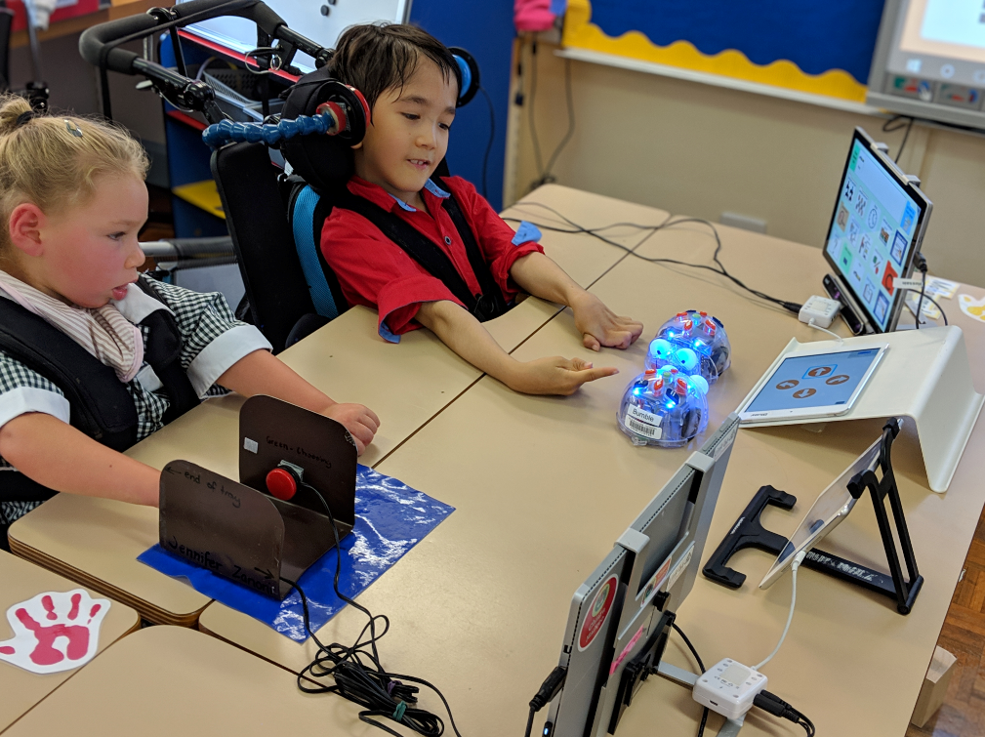

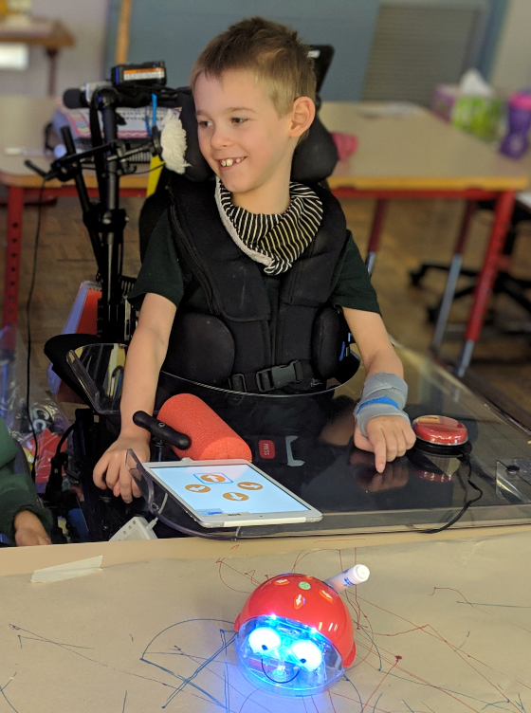

Caption: Students at Glenallen School, Victoria participating in DLSG activities

