OUR eSMART JOURNEY
Making a difference
Summary
Sally Hill, eLearning Coach at Point Cook P–9 College, explains some of the key stages and elements of the college’s whole school approach to eSafety and being eSmart.

Our focus
‘Make an impact on student lives.’
This is why most teachers come to work every day. It’s why I come to work every day.
When we started our eSmart journey with the Alannah & Madeline Foundation I never knew how much of an impact we could have in educating our students on cyber safety. There was so much to consider, from having policies in place to auditing what the college already did in cyber safety education, and more. Fortunately, at Point Cook College our leadership team is extremely supportive of this movement and could see the need for such a program, especially having a one-to-one iPad program.
For me it didn’t just stop there. I wanted to make an impact. I needed staff buy-in, I needed student buy-in, and I needed support from parents.
Creating an e-Smart team
Creating an eSmart team is one of the first major things we implemented at the college. We asked for a teacher representative from each year level who would commit to a meeting every fortnight. We were looking for staff members who were enthusiastic and committed to the eSmart journey. Having this staff team was so important and it helped take our journey off the ground and reach new horizons. It became the backbone for our success.
Our student eLeaders
Our student team, the eLeaders, was our next big thing. We wanted a team of students from years 3–9. These students would develop resources for other students to share across the college, continuing the enrichment of online safety, digital citizenship and 21st century learning. Our staff chose 21 students, three from each year level, who were presented with an eLeader badge and congratulations letter from our principal. One of the most important factors of putting our eLeader team together was for students to have a voice and to become the champions of change for our school community.
A whole school event
Whilst working through our eSmart journey with our staff team and our eLeaders, we planned our inaugural whole school Cyber Safety Day. On this day students would learn about Cyber Safety and being digital citizens.
Students participated in various classroom and whole school activities. We had two giant footprints taken around the school. Students contributed their thumbprints and pledged: ‘Cyberbullying free @PCC’.
We went onto our school oval and had students pose as the words digital, learners, cyber, safety and eSmart whilst our drone was up in the air taking aerial photos. We sold PCC Cyber Safety wristbands that were designed by our eLeaders. The wristbands read ‘Cyber Bullying Free @ PCC’. All money from the wristband sales went to the Alannah & Madeline Foundation. They ended up being so popular we had to order more and kept selling them for three weeks after! The whole school Cyber Safety Day is now a permanent annual event on our calendar.
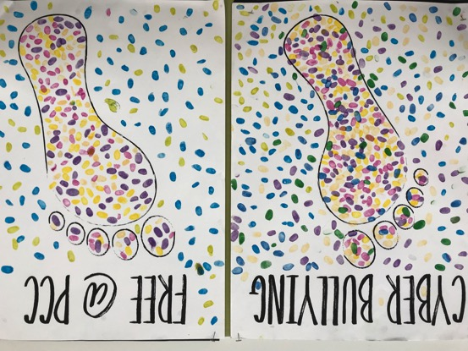
Credit: Point Cook College
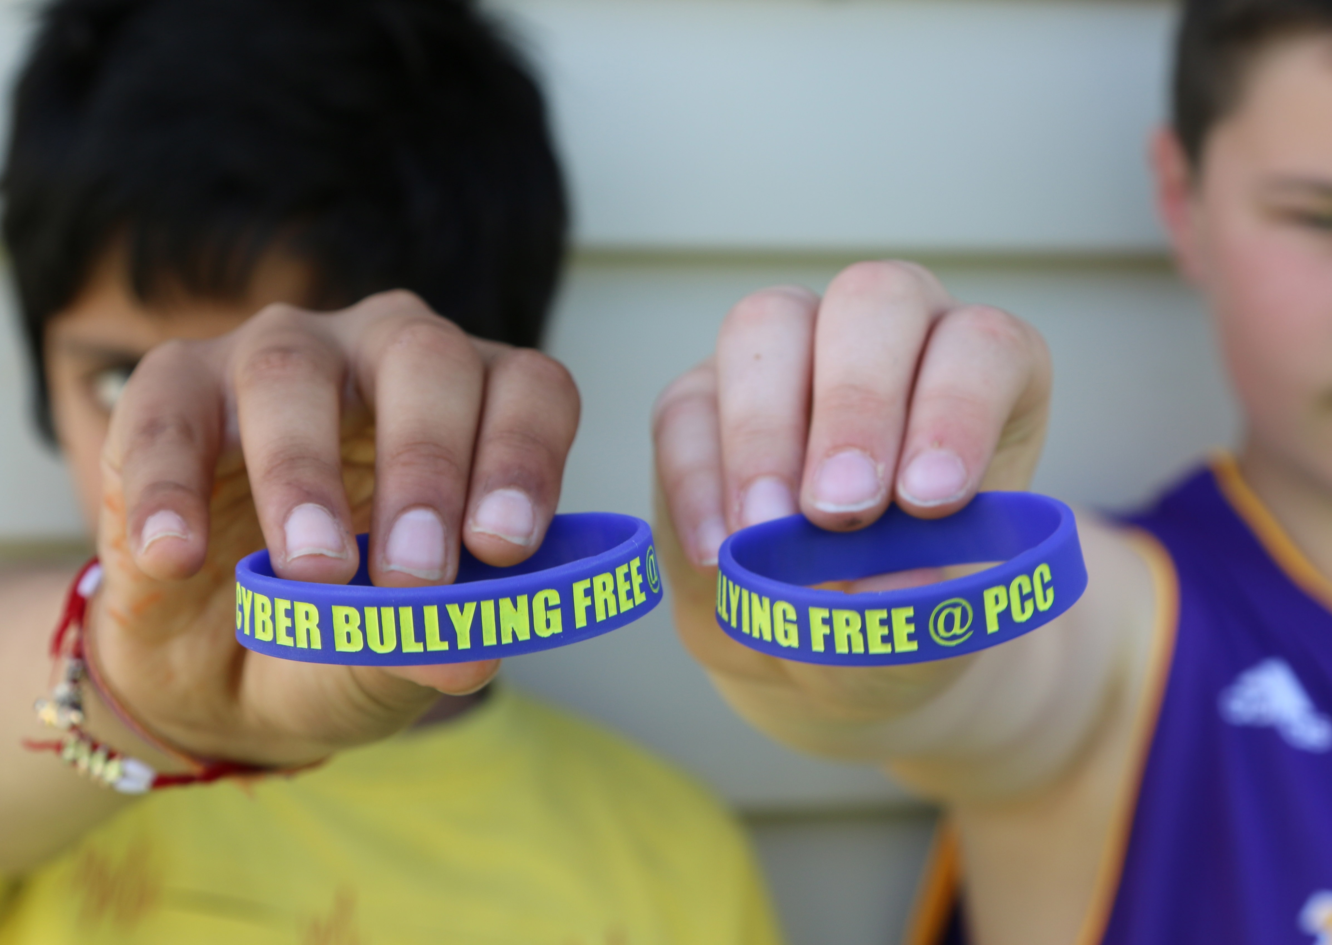Credit: Point Cook College

Credit: Point Cook College
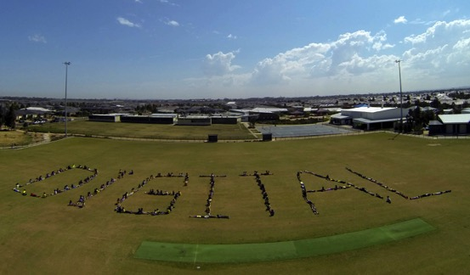
Credit: Point Cook College
From this day came our Cyber Safety Mascots. We held a competition for our students to design a mascot for the school. We had so many applicants that the eLeaders struggled to pick one. So we made the executive decision to merge two of the top designs into one team. We also asked one of the students to redraw them all and from there we had four mascots: Nexa, Firewall, Virus Scanner and Filter, each with their own unique look and style. The students loved our new team, and posters went up in rooms so that they could be referenced and looked at.
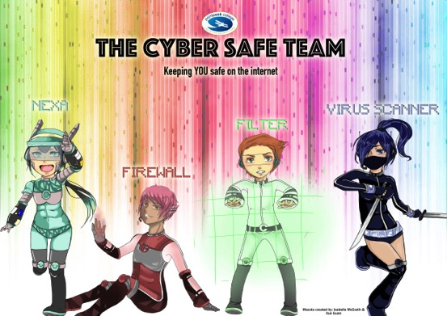
Credit: Point Cook College
Promoting and integrating the Cyber Safety Mascots
Having our Cyber Safety Mascot team posters around the school was great but we needed to do more with them. We wanted our students to not only learn from them but to share them with their families. I had decided to investigate a Cyber Safety Mascot Program with our years 1 and 2 students. The idea behind this program was to take the learnings of cyber safety and digital citizenship into our students’ homes. This way they could share their understandings with family and friends.
Fortunately, our talented Assistant Principal Jenny Hayes is also a sewing queen. She kindly donated her time and skills to create our four mascots into actual dolls. To her credit the dolls are amazing! Through collaboration with the Neighbourhood Leader and years 1 and 2 teachers a book was created with activities for each mascot. These activities ranged from digital footprints, emails, safe searching, online identity, copyright, balancing your time online and more.
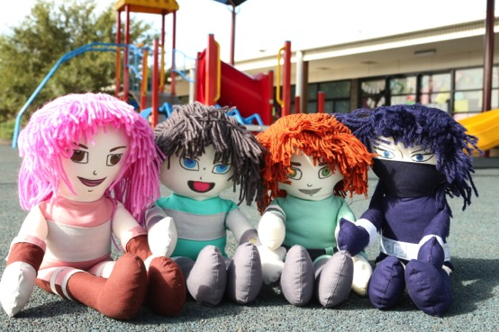
Credit: Point Cook College
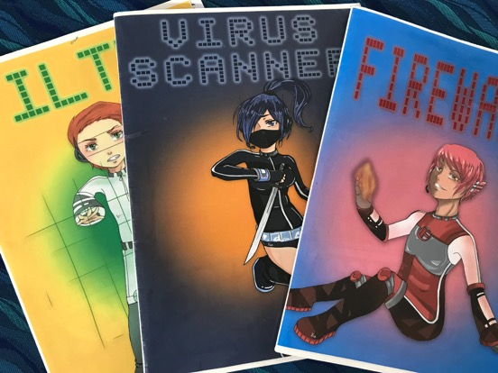
Credit: Point Cook College
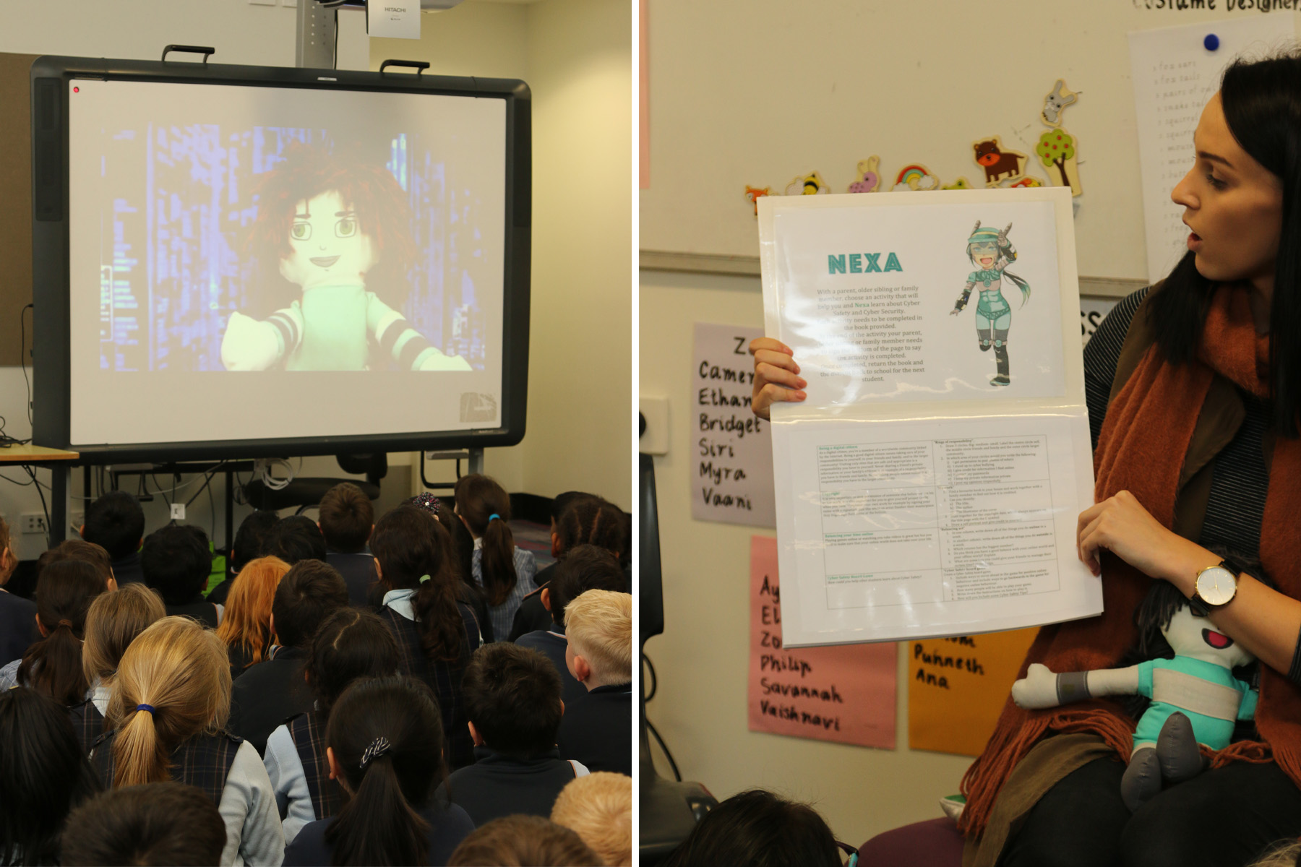
Credit: Point Cook College
The take home activity
Having the teachers’ support in the program was extremely beneficial. When it came time for us to launch the Cyber Safety Mascot Program the teaching team took our mascots to the green screen and filmed a fantastic video introducing the four characters. They spoke about how the characters had been trying to stop the evil ‘Malware’ from attacking the Point Cook College community. They said each mascot would end up in each room. The students were extremely excited about this and couldn’t wait to take their newest class member home to show their families.
Watch our Cyber Mascot introduction video.
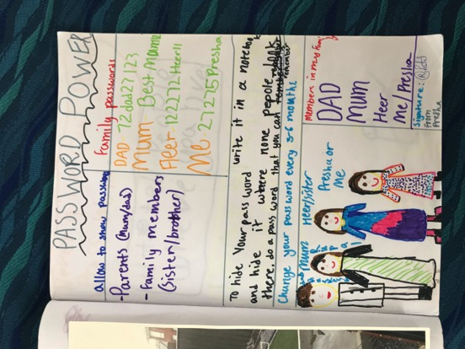
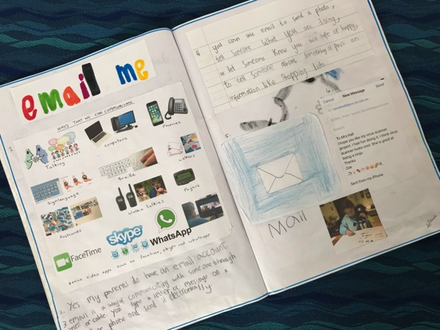
Credit: Point Cook College
Where to next?
Our journey doesn’t stop here. Next year, we will be launching our Cyber Safety Mascot Program to the whole years 1–2 cohort. Our eLeader team will be participating in kids-teaching-kids programs and extending their leadership skills out to our community. We also hope to run workshops with other schools that have similar programs.
We have also been working on a whole school eSafety curriculum that will run from Prep to Year 9 in 2018.
Advice
- Any school wanting to run a program similar to our story should begin with gathering a team of teachers who are passionate and committed to online safety.
- Create a school declaration against cyberbullying. As a school, have a shared vision and goal of allowing students to be safe online.
- Mentor a group of students to lead in the education of other students. Students need to be co-designers and co-researchers. Give the platform over to the young people to hear their voices, as young people are the best agents for change within their school community and online.
- Include parents along the way. Parents want to be involved but just don’t know how. When you run information sessions, Mother’s Day or Father’s Day events, plan for students to educate their families about online safety. This helps to start the conversation between parents and kids.

About Point Cook P–9 College
At Point Cook College, we are committed to providing 21st century education. Academic rigour is valued at all stages with a consistent and high quality curriculum that develops individual pathways and realises the potential of every student. The Point Cook College learning community is underpinned by our vision of ‘creating tomorrow today’.
Point Cook College opened in 2010 as the re-location of Point Cook Primary School, which had operated on the RAAF Williams Point Cook Base since 1923.
Learning Technologies are an integral part of everyday teaching and learning within the college. Years 3–9 students have a parent-funded one-to-one iPad program. Years P–2 students have access to multiple class sets including iPads and netbooks. All teaching and learning spaces have an interactive whiteboard (including specialists) and high-speed internet connectivity due to continuously upgraded infrastructure.
The college values and encourages partnerships and expects all of the learning community to uphold the goals of the college. This will be achieved through:
- fostering close links with parents and the broader college community through its commitment to open and regular communications
- committing to the active sharing of its vision and goals to ensure college community engagement in the strategic plan
- guaranteeing all students have access to a broad, balanced and flexible curriculum
- providing a safe and stimulating learning environment to ensure all students can achieve their full potential
- providing students with instruction that is adapted to their individual needs
- responding to all communication by parents and caregivers in a timely manner
- providing teachers with timely and targeted feedback to students on their work and behaviour.
We are very proud of our college and invite you to find out more at our website.

