This is a collection of data.
It is a display of the lunches for a class of students.
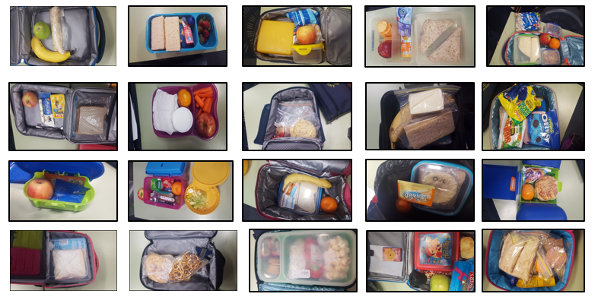
What is the total number of lunch boxes in this display? __
Why is it important to know the total number in a collection of data?
_________________________________________________________________________________________
Digital Technologies Hub is brought to you by
Creative Commons BY 4.0 licence unless
otherwise indicated.

Australian Government Department of Education and Training
Page 1 of 4
Here is the data represented as a table, showing only the fruit.
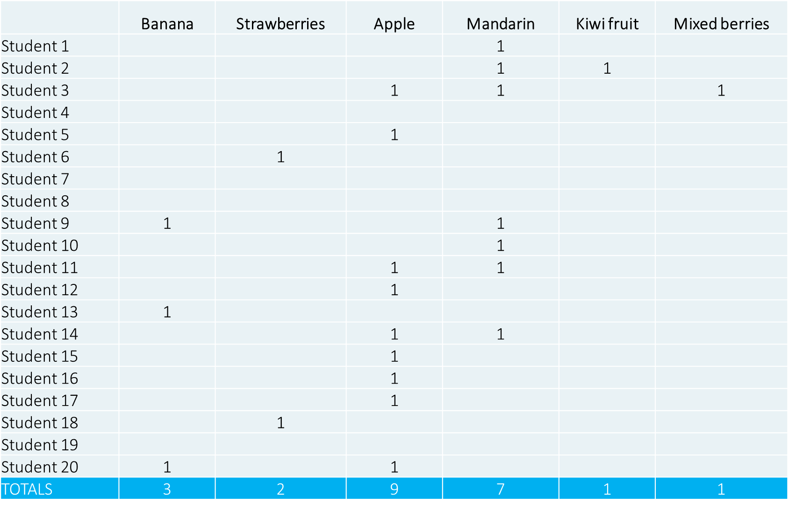
- What is the most common fruit? ______________
- How many students brought more than one type of fruit in their lunch box? __________
Digital Technologies Hub is brought to you by
Creative Commons BY 4.0 licence unless
otherwise indicated.

Australian Government Department of Education and Training
Page 2 of 4
- How many of the students do not have fruit in their lunch box? _____________________
Circle the graph that correctly displays the number of lunch boxes with no fruit for this data?
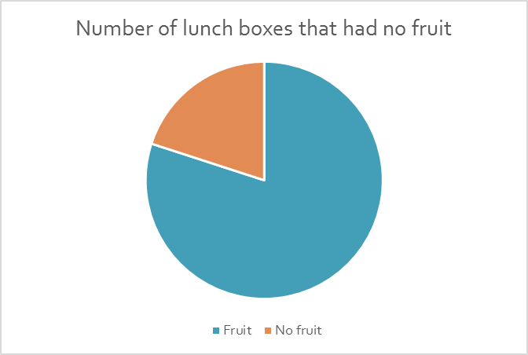

What is the highest number of fruit in this set of data? ___ What is the lowest number of fruit in this set of data? ___
Why is this important when creating a graph? ______________________________________________________

Look at the data again. Order the fruits from least to most.
___________ ___________ ____________ ___________ ___________ _____________
Why do we often put data in an order?
__________________________________________________________________________________________
Digital Technologies Hub is brought to you by
Creative Commons BY 4.0 licence unless
otherwise indicated.

Australian Government Department of Education and Training
Page 3 of 4

Here is the data, each fruit represented as an image.  Label the graph so it makes sense.  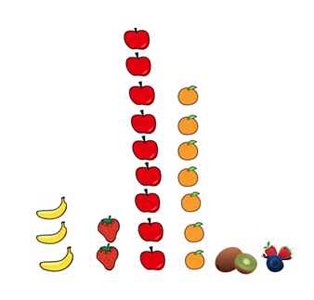  Why do we use graphs to display data? | Instead of images, represent the data as columns in a chart called a column graph.  If possible use computer and a spreadsheet to create your chart.
__________________________________________________________________________________________
Digital Technologies Hub is brought to you by
Creative Commons BY 4.0 licence unless
otherwise indicated.

Australian Government Department of Education and Training
Page 4 of 4

