Digital Literacy Schools Grants (DLSG) Case Study:

Korowa Anglican Girls’ School, Victoria

DLSG Round 1 Grant amount: $50,000

School Profile
Korowa Anglican Girls’ School is a non-government school in Glen Iris, Victoria and has a student population of 759 students from Preparatory to Year 12. The school’s programs aim to develop the skills of knowledge building, collaboration, self-regulation, problem-solving, creativity and innovation, metacognition and the use of learning technologies. Senior students have an extensive range of VCE subjects to choose from, together with a diverse co-curriculum. Learning takes place within the context of a digital environment and students leave the school with high levels of digital literacy. Korowa Anglican Girls’ School is proactive in promoting the positive, safe and ethical use of all technologies.

Focus of the Grant Activity
Funding from DLSG program to Korowa Anglican Girls’ School contributed to the establishment of a makerspace, known as The STEAM Lab at the school. The STEAM Lab is used extensively by dedicated Technology and Enterprise classes as well as by other classes across the curriculum who have integrated technology and design into their programs.

External professional experts provided learning opportunities to upskill teachers in implementing the Australian Curriculum: Digital Technologies through support and mentoring. Teachers were able to acquire greater depth of understanding of STEAM, the Digital Technologies curriculum and its authentic integration within the Australian Curriculum.

The auditing of the curriculum and development of learning ladders to map student progress towards a higher sophistication of thinking and application of technology as their knowledge and skills increase. The scope and sequences and the development and implementation of curriculum units and associated resources has helped teachers deliver targeted programs for their students. For example, Year 7 students developed a project involving History, Technology and Enterprise utilising digital tools including CAD (computer-aided design) software.

Successful ongoing relationships have taken place in the digital technology and general STEAM field with Lloyd Primary School, Malvern Primary School, Malvern Valley Primary School Glen Iris Primary School and St Roch’s Primary School and broadened the scope of the network with these schools.

What advice would you give other schools wishing to undertake a similar activity?

One of the best strategies we applied to assist teachers across the whole staff in becoming more comfortable with using technology, was to provide voluntary sessions where staff could learn about and tinker with a particular technology tool. These staff then went away to apply in their subjects and then would presented at a regular teach meet held at the end of the term. This in turn, inspired other staff to apply this technology.

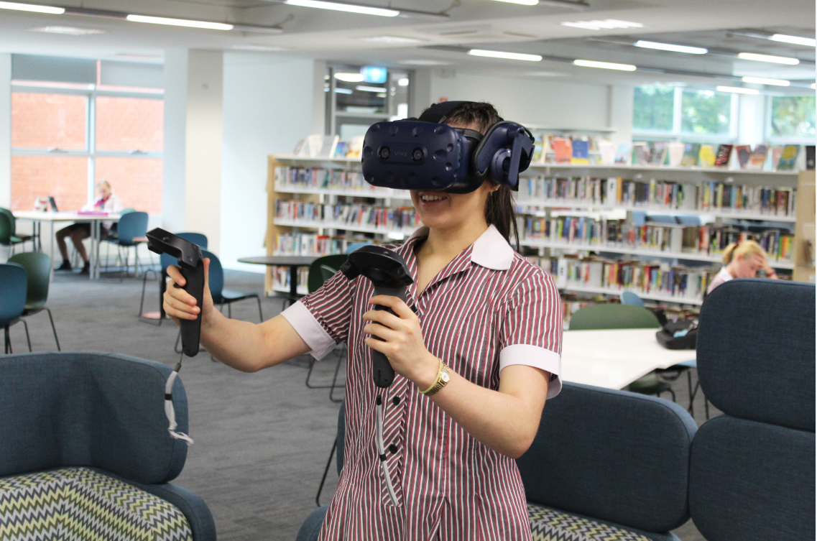
Having a STEAM Futurist, (a staff member associated with the STEAM Lab) who can research, tinker and support teachers with learning how to use technology tools was crucial. It meant that we felt assured that through the extensive research conducted, we were able to select technology tools best suited for our purposes. The training and mentoring of staff by the STEAM Futurist meant that staff felt more confident when they went to apply the technology to their program.

