Impact of climate change on flatback turtle populations

**YEARS 7–8**

*Please refer to the online lesson plan on the DT Hub to access all website links and additional resources.*

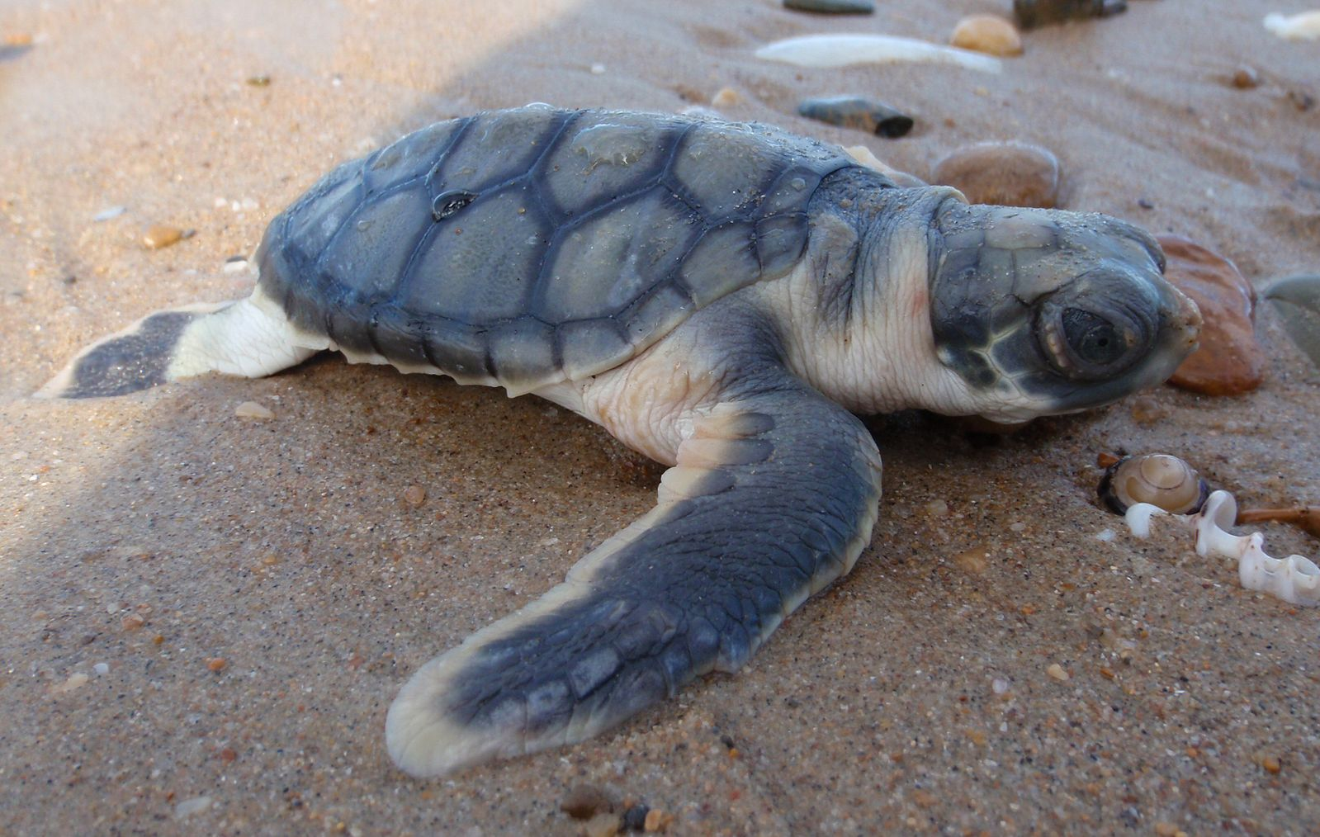

Image: Juvenile flatback turtle (*Natator depressus*)

**Learning Hook**  
Sand temperature is important for turtles as the sex of hatchling turtles is determined by the temperature of the sand where the eggs incubate. Warmer temperatures will translate into more females and colder temperatures into more males. The temperature at which half of the eggs are male and half are female is called the *pivotal temperature*. For flatback turtles the pivotal temperature is around 28 ˚C. Scientists have placed temperature-logging equipment at flatback turtle nesting beaches across Western Australia.

The lesson follows an inquiry process in which students use a dataset to answer relevant questions about the turtle population. They consider how to analyse and display the data in order to effectively examine the impact of rising global temperatures on flatback turtle populations.

This lesson was created and developed in partnership with Pawsey Supercomputing Centre and Western Australian Marine Science Institution (WAMSI) Kimberley Marine Research Program. Turtle data was sourced from the WAMSI project, which is funded by the Western Australian State Government and research partners. Data is licensed under the Creative Commons BY-NC-SA 2.5 AU licence.

**Keywords:** Data science, Dataset, Fauna data, Flatback turtles, STEM, Science, Scientific method, Higher order thinking, Spreadsheets, Data representation, Data analysis, Data visualisation, Excel, Numbers, Cross-curriculum priorities, Sustainability

**Learning intentions**

* Use relevant techniques to clean up data (eg remove blank rows).
* Save, store and use CSV files.
* Use spreadsheeting software to sort and filter data to help answer inquiry questions.
* Analyse data and look for patterns.
* Create graphs such as a bar graph to present data.
* Select the most suitable graphing format to visualise and present data.
* Use higher order thinking skills (interpreting, analysing, inferring, summarising and evaluating).
* Use data and the results of data analysis to create persuasive media to encourage the general population to consider the impact of climate change.

Suggested steps

1. Use a relevant hook to engage students to discover more about flatback turtles.

* Use a quiz to stimulate interest in marine turtles and discussion of some key concepts.
* Use the online 3D model of a flatback turtle to introduce the species. How is it similar and different to other turtle species
* A scenario could be introduced to encourage students to consider a range of issues and concerns to explore the impact of climate change. In the student task we have used the scenario: *What happens to flatback turtles if the global temperature rises by 1.5 ˚C, 2 ˚C or more?*

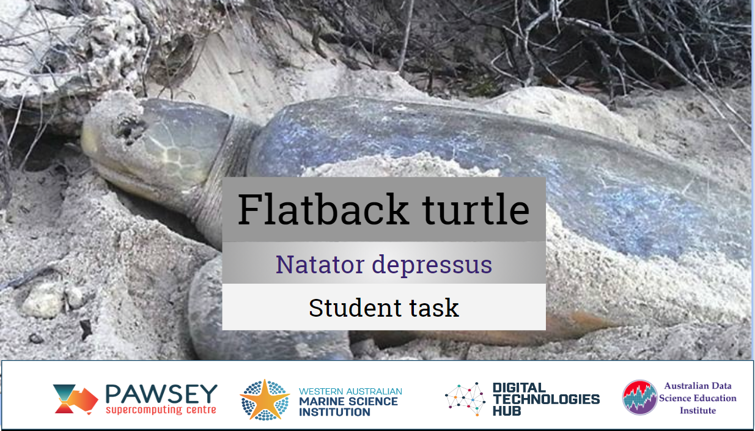

Girls in focus: Research has shown that many girls are interested in careers that have a positive social impact. This topic shines a spotlight on a contemporary issue that requires a balance of social, ethical, economic and conservation perspectives.

1. Briefly discuss students’ knowledge or experiences of climate change and what they know in particular about the impact of climate change on turtle populations. The sex of turtle hatchlings is determined by the temperature of the sand. Introduce the concept of pivotal temperature – the nest temperature at which 50% of hatchling turtles are male and 50% are female.
2. Introduce the scientific study conducted to gather data to understand sand temperature and its impact on turtle hatchlings. Provide the dataset ‘Rookery temperatures’. Organise students into collaborative teams to investigate the scenario and develop their media product.

*About the dataset*

The temperature loggers are buried 50 cm deep in the sand (the average depth of a flatback turtle nest). They begin recording temperature a few days before deployment. Once deployed, loggers are left in the sand for about a year, recording temperature every hour. They are then dug up and their data is downloaded before they are re-buried in the sand.

Information about the datasets provided as Excel files for six sites:

(Please refer to the online lesson plan on the DT Hub to access all website links and additional resources.)

Nesting site 1: Logger 11011631 was deployed at Eco Beach (-18.27059, 122.16515). The logger is programmed to measure temperature every hour. It was deployed in the sand on 21 November 2016 and recorded data until 2 December 2018. Statistical guidance is provided.

Nesting site 2: Logger 11023114 was deployed at 80 Mile Beach (-19.599209, 121.023961). The logger is programmed to measure temperature every hour. It was deployed in the sand on 14 November 2016 and recorded data until 13 July 2018.

Nesting site 3: Logger 11011630 was deployed at Cape Domett (-14.79849, 128.415512). The logger is programmed to measure temperature every hour. It was deployed in the sand on 28 November 2017 and recorded data until 5 August 2018. Statistical guidance is provided.

Nesting site 4: Logger 11023106 was deployed at Shark bay (-25.75716667, 113.6649167). The logger is programmed to measure temperature every hour. It was deployed in the sand on 3 January 2017 and recorded data until 8 January 2018.

Nesting site 5: Logger 20213219 was deployed at Delambre Island (-20.46485894, 117.07438). The logger is programmed to measure temperature every hour. It was deployed in the sand on 26 November 2017 and recorded data until 23 November 2018.

Nesting site 6: Logger 11000809 was deployed on Thevenard Island (-21.45675, 114.9886). It was programmed to measure temperature every hour. It was deployed in the sand on 9 December 2017 and recorded data until 15 November 2018.

Girls in focus: Research has shown that many girls value interaction and collaboration. Promote collaboration and recognition of the varied skills within the team, ensuring that all students are given the opportunity to manipulate the dataset.

1. Depending on your students’ skills and familiarity with spreadsheeting software, such as Excel, Numbers and Google Sheets, you may decide to scaffold their introduction to the dataset or let them explore the dataset based on a question of interest.

Girls in focus: Girls often have poor self-confidence about mathematics, believing commonly held stereotypes that boys are naturally better than girls at maths. If you observe a number of girls showing reluctance or a lack of confidence with using spreadsheets, consider offering an additional session to practise and improve their skills. Support a growth mindset by praising their effort, strategies and behaviours.

1. Use the Flatback turtle: Student task presentation slide deck, which provides a guide to students’ inquiry.

*About this enquiry*

This enquiry provides an opportunity to consider the issues of scientific data collection in the marine environment, and to extend scientific understanding by designing new experiments to fill gaps in existing data and knowledge.

In many scientific endeavours the data collected is a proxy for the data we really want. In this case we have data that measures the sand temperature, but we lack actual data on the sex of the resulting hatchlings. We don’t know how long the temperature needs to be outside the viable range before the eggs die, and we don’t know how long it needs to be higher than the pivotal range before the hatchlings all become female.

We will approximate using averages and percentages, but it is important to discuss the limitations of this approach. To be more accurate, we need to understand more about how temperature affects turtle eggs and hatchlings, and we simply don’t have that data because it has not yet been studied in enough detail.

1. Working with the data in your preferred spreadsheet package, explore ways of making sense of the CSV file. Open the Rookery temperatures data in a spreadsheet program such as Google Sheets, Excel or Numbers. There are two sets of data (two sheets) and more than 6000 rows of information, which is a challenge to make sense of at first glance. How do we understand the data?

*Developing a data science mindset*

**Always make a copy.** Before you do anything, duplicate the spreadsheet and save it on your computer or network. This way you have a new copy of the data, and the original remains untouched. Rename one spreadsheet ‘original’, and one ‘copy’. Work in the ‘copy’ sheet, not the original. This ensures that you can always go back to the untouched data. This is good practice when doing data analysis. Never edit your original dataset!

1. Start by using conditional formatting to highlight the times the data goes outside the viable range. We want to know how much of the time the temperature is outside the viable range, and how much of the time the nest temperature will produce only males, or only females. As a class, discuss how best to display this data. One technique is to use conditional formatting, as we have done above.
2. Start with a line graph to show the change in temperature over time.

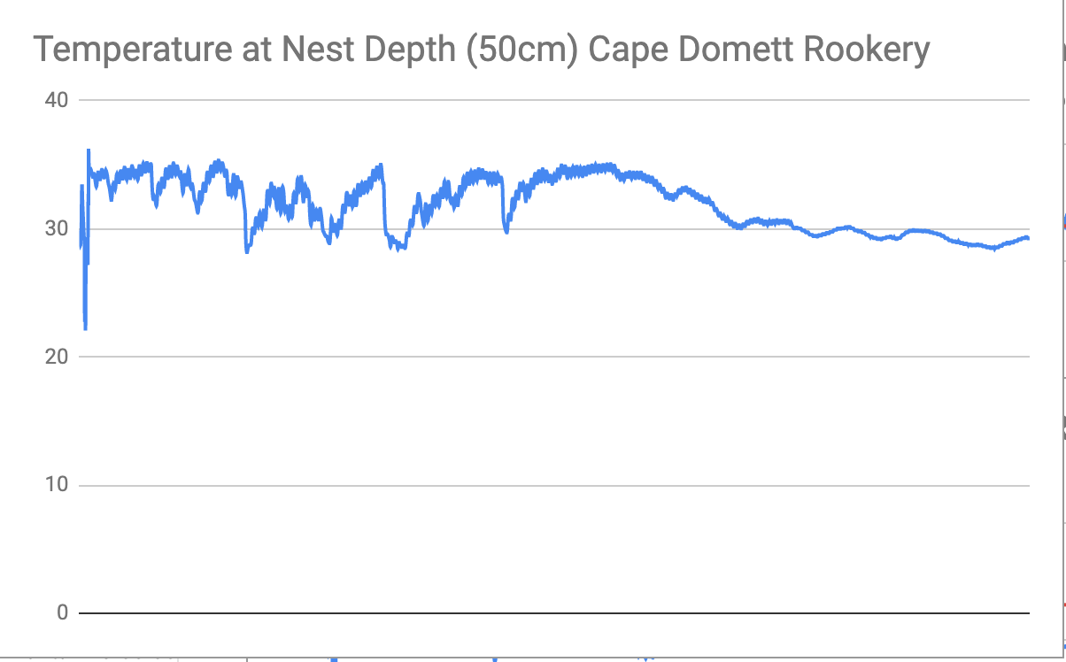

1. Now add in a line to show the 33 ˚C maximum viable temperature. The simplest way to do this is to create a column of all 33s, as long as the column of temperatures, and then graph the two columns together as line graphs.

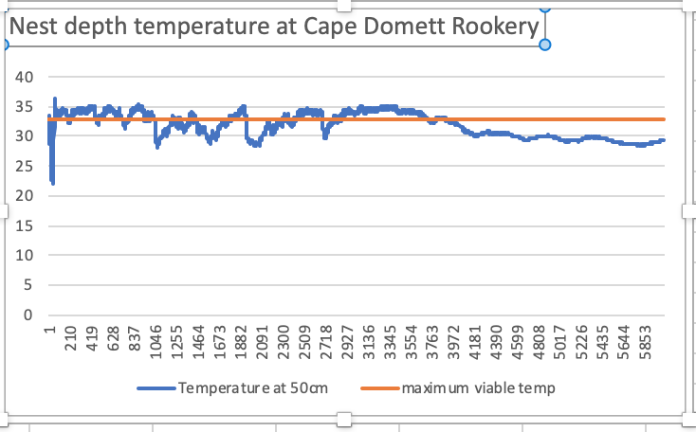

1. Discuss setting appropriate labels for both of the lines as well as a meaningful title for the graph as a whole. Note that the simplest way to label the lines well is to change the heading labels for those columns in the spreadsheet.
2. Ask students: *What kind of graphs might you use to show the amount of time hatchlings will be: non-viable, male only, a mix of male and female, and female only?*

Discuss as a class what you are trying to convey with this graph, and what the best type of graph would be to show this. Student may suggest a pie chart (circle chart), used for showing data as a percentage. For this exercise compare the same data presented as a bar chart and a pie chart and discuss the benefits and limitations of each.

As with all forms of communication, the important questions are: *What are you trying to say?* and *What do you want the reader to understand from this graph?*

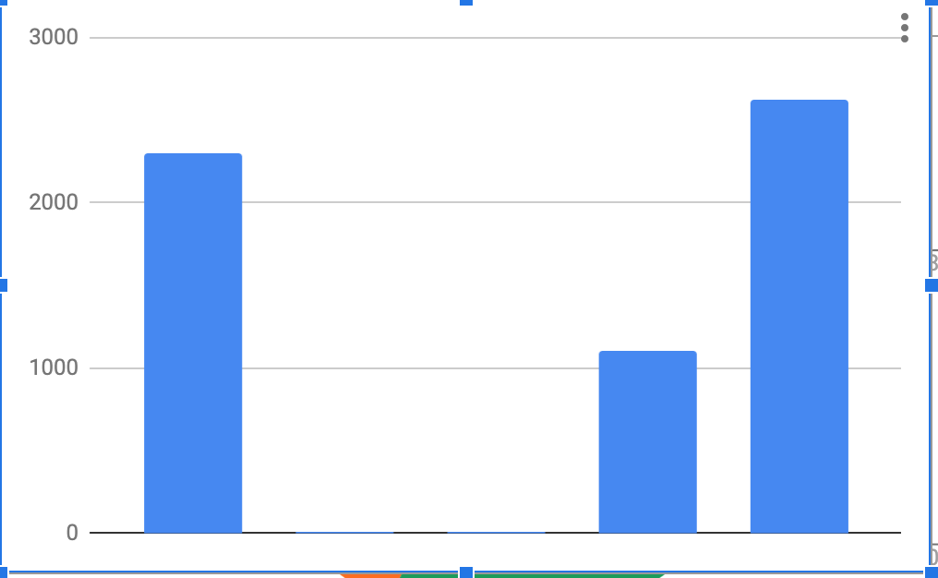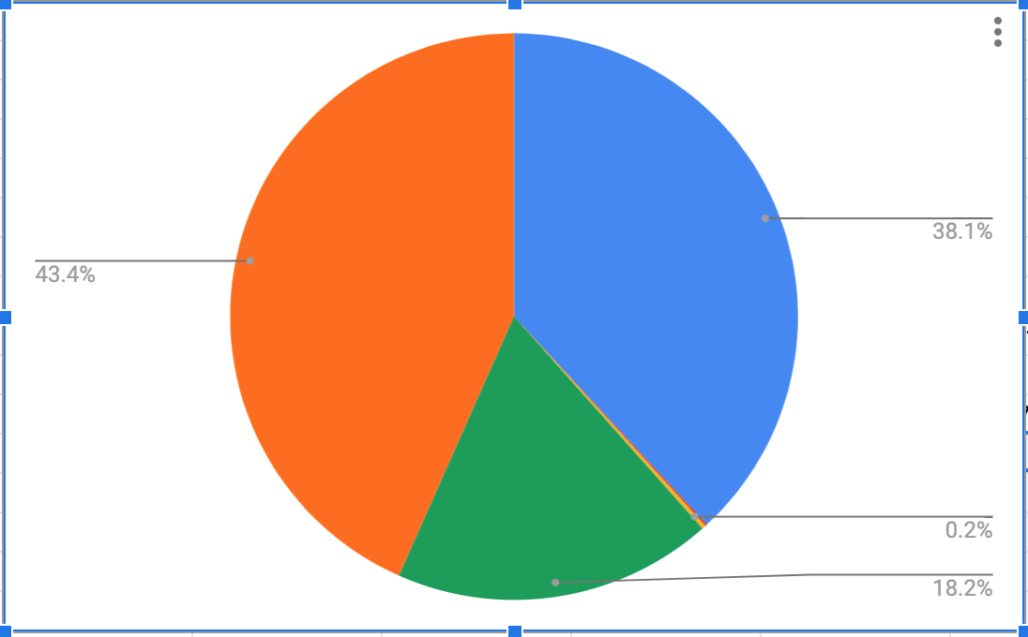

As a class, discuss labelling of the charts and how this helps understanding. Make sure the students’ charts have titles, labels on each of the parts of the graph and legends. Also discuss how the big variations in values (for example the limited values for ‘males only’ in the Cape Domett data) make some of the sections of the chart difficult to read.

1. Calculate the average nest temperature for each month by highlighting the temperatures for that month and using the average function. Discuss how the nest site temperature differs from the average temperature for that location for that month. Consider how the nest depth temperature may differ from the ambient air temperature.

Scientists are recommending that to avoid the worst effects of climate change we need to keep the temperature increase to 1.5 ˚C, or 2 ˚C at most. What would be the impact on the turtles’ viability if the temperature rose by just 1.5 ˚C? What about 2 ˚C? As a group, discuss the kinds of calculations that would give you the best idea of the impact of such an increase in temperature.

One way to understand the effect of an increase in temperature is to calculate the percentage of time the nesting sites are currently viable, and how that would change given a 1.5 ˚C or 2 ˚C increase.

Remember that over 31.3 ˚C the nests will produce only female hatchlings, which makes the population unviable as there would be no males for reproduction. Calculate the percentage of time the turtle nesting sites are currently non-viable (ie produce no live hatchlings, or only females). Use the ‘Countif’ function to calculate the number of cells over 31.1 ˚C. Calculate the total number of cells. Divide the number of cells over 31.1 ˚C by the total, and multiply by 100. Use the screenshots in the slide set as a guide to constructing the ‘Countif’ formula.

**Remember that to make a formula in a spreadsheet you MUST put = at the beginning, otherwise the spreadsheet will treat it as text, not a calculation.**

*Extension coding activity*

We don’t actually know how long the temperature has to be out of range to affect the viability of the eggs. Students who are familiar with the Python programming environment, and who can write a program, could create a program that allows a user to input different lengths of ‘out of range’ time (say, 1 hour, 3 hours, 1 day). They could then see how this affects the total viability of the nesting site.

1. Ask the class groups for each nesting site to construct graphs that show:
   1. the current proportion of time for which the nesting sites are viable
   2. the proportion of time for which only females will hatch
   3. how much the temperature needs to rise before the nesting sites are producing only females for at least 80% of the time.
2. Provide an opportunity for groups to share their results so that each group can compare results and graphs for both nesting sites. Discuss different ways the data has been represented, considering the advantages and disadvantages of each technique.
3. **Apply what students have found**

Using the results and graphs, students highlight the turtles’ plight, and the effect of a 2 ˚C increase in global temperature. They can create an infographic, video or slide presentation to inform or persuade the public to care more about climate change.

**Design a digital solution**

Scientists need data about the numbers of hatchlings that emerge from each nest. Students design a digital system that automates the process of monitoring the emerging hatchlings. Discuss with students the use of sensors to track movement, video cameras that operate at night and how the systems require power (battery/solar and battery).

Girls in focus: Research suggests that many girls are motivated when they are given opportunities to approach projects their own way, exercising their personal preferences and creativity. Engaging with creative problem-solving also encourages students to embrace failure as part of the learning process, building resilience.

**Why is this relevant?**

**Acquire data:** Acquiring data is how we collect and access data from a variety of sources. Students can generate data of various types through their own experiments and investigations.

**Store data:** Record data in a format that allows it to be easily accessed or obtained. Students can describe how the data they have acquired can be stored in different ways using different representations and/or software. It is important to select the most suitable representation.

**Organise data:** Organising data relates to the ways we order, sort and arrange data to assist us with interpretation in different contexts.

**Interpret data:** Use data and its characteristics, properties and patterns to form a conclusion or derive meaning from it. Students can work with data that requires some simple processing using software. This could be in the form of simple spreadsheet calculations or using data in code. Students draw conclusions about the data as a result of this processing.

Assessment

Negotiate assessment with the class. Use the following marking guide as a starting point.

Discuss how teams may use the negotiated marking guide as a self-evaluation tool.

**Communication project**

|  |  |  |  |  |
| --- | --- | --- | --- | --- |
| Experimental design and data analysis | 1 | 2 | 3 | 4 |
| Research into marine turtles (ICT capability) | I didn’t use any references. | I viewed up to three references and recorded brief notes. | I viewed up to three references and recorded notes in a table to organise the information. | I viewed more than three references and recorded detailed notes in a table to organise the information. |
| Turtle dataset and using a spreadsheet  (digital technologies) | I didn’t use the turtle dataset. | I sorted the turtle dataset to help answer a question.  I created a chart to present the data visually. | I created several charts to present the data visually.  I can explain which chart best displayed the information.  My charts were well labelled. | I selected the chart(s) that best displayed the information.  I was able to draw conclusions from the data and create relevant information used in the communication product. |
| Science  (experimental science) | I did not use scientific ideas. | I can describe ways that turtle populations may be affected by an increase in global temperatures. | I can explain why turtle populations may be affected by an increase in global temperatures and link this to climate change. | I can explain why turtle populations may be affected by an increase in global temperatures. I can link this to climate change and give examples using data to back up claims. |
| Turtle communication product  (digital technologies) | I did not use any data in my communication product. | I used one chart in my communication product. | I used several charts and chose the most appropriate to help inform/persuade the audience. | I used several charts and chose the most appropriate to help inform/persuade the audience.  I did further research to examine relevant additional data. |

Digital design project

|  |  |  |  |  |
| --- | --- | --- | --- | --- |
| Experimental design and data analysis | 1 | 2 | 3 | 4 |
| Design  (digital technologies) | I hand drew a diagram of my idea showing the equipment I need. | My labelled diagram design shows the parts I need and the role they play. | My design shows the system I am using, showing how the parts are connected. I have labelled the parts with the role they play in the system. | My design shows the system I am using, showing how the parts are connected. I have labelled the parts with the role they play in the system. I have clearly explained how my system is automated. |
| Prototype of my digital design (technical and usability, digital technologies) | I didn’t create a prototype. | My prototype is made up of the parts I identified in my design However, I am finding some challenges in getting it to operate. | My prototype is made up of the parts I identified in my design in the system. I overcame the challenges, and it operates. I considered how scientists would use the system. | My prototype works effectively, and I can use it to explain and demonstrate how it would sense movement and record the hatchlings emerging from a nest.  I can explain how scientists would use the system to gather data and assist with their data collection. |
| Prototype of my digital design  (digital technologies: economic and sustainability) | I did not consider sustainability or economic factors in my design. | I can describe how I could make this more sustainable.  I can describe the costs of my design. | I considered sustainability in my design and can describe these aspects.  I can explain the choice of equipment and justify the costs of my design. | I can explain ways I considered sustainability in my design, giving clear examples. I can give reasons for my choice of equipment and justify the costs. I can link the costs to scientists' time. |

Resources

Resources

* Flatback turtle: Student task presentation slide deck
* Turtle quiz

Datasets

* Logger turtle data - Eco Beach (xlsx file)
* Logger turtle data - 80 mile beach (xlsx file)
* Logger turtle data - Shark Bay (xlsx file)
* Logger turtle data - Delambre Island (xlsx file)
* Logger turtle data - Cape Domett (xlsx file)
* Logger turtle data - Thevenard (xlsx file)

Flatback turtle information

* Flatback turtle (Natator depressus)
* What do sea turtles eat? Unfortunately, plastic bags

Video tutorials (spreadsheeting tips)

* Graphing and mean, median and mode
* #1 Excel Tutorial on the Net - Excel Easy

Australian Curriculum alignment

## Digital Technologies

Years 7–8

* Acquire, store and validate data from a range of sources using software, including spreadsheets and databases (AC9TDI8P01)
* analyse and visualise data using a range of software, including spreadsheets and databases, to draw conclusions and make predictions by identifying trends (AC9TDI8P02)
* define and decompose real-world problems with design criteria and by creating user stories (AC9TDI8P04)

## Science

Years 7–8

* Plan and conduct reproducible investigations to answer questions and test hypotheses, including identifying variables and assumptions and, as appropriate, recognising and managing risks, considering ethical issues and recognising key considerations regarding heritage sites and artefacts on Country/Place (AC9S7I02 ), (AC9S8I02 )
* Examine how proposed scientific responses to contemporary issues may impact on society and explore ethical, environmental, social and economic considerations (AC9S7H03 ), (AC9S8H03 )
* Explain how new evidence or different perspectives can lead to changes in scientific knowledge (AC9S7H01 ), (AC9S8H01 )
* Analyse data and information to describe patterns, trends and relationships and identify anomalies (AC9S7I05 ), (AC9S8I05 )
* Analyse methods, conclusions and claims for assumptions, possible sources of error, conflicting evidence and unanswered questions (AC9S7I06 ), (AC9S8I06 )
* Construct evidence-based arguments to support conclusions or evaluate claims and consider any ethical issues and cultural protocols associated with using or citing secondary data or information (AC9S7I07 ), (AC9S8I07 )
* Write and create texts to communicate ideas, findings and arguments for specific purposes and audiences, including selection of appropriate language and text features, using digital tools as appropriate (AC9S7I08 ), (AC9S8I08 )

Mathematics

Years 7–8

* Describe relationships between variables represented in graphs of functions from authentic data (AC9M7A04 )
* Acquire data sets for discrete and continuous numerical variables and calculate the range, median, mean and mode; make and justify decisions about which measures of central tendency provide useful insights into the nature of the distribution of data (AC9M7ST01 )
* Investigate techniques for data collection including census, sampling, experiment and observation, and explain the practicalities and implications of obtaining data through these techniques (AC9M8ST01 )