Page 1 of 2
Year: F-2 | Title: Glyphs
Assessment task
Students collect, explore and sort data about themselves and their classmates using a range of themes. A glyph is a pictorial representation of data, in this case, to be presented as a digital artwork.
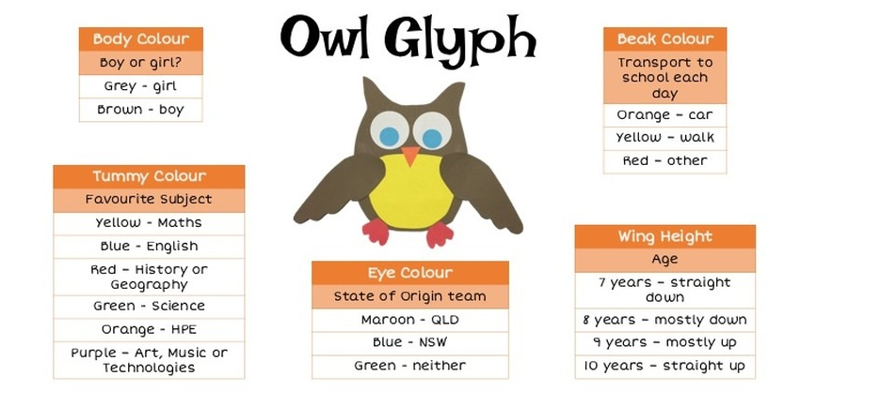
Relevant Australian Curriculum: Digital Technologies achievement standard
Collect familiar data and display them to convey meaning.
Use digital systems to represent simple patterns in data in different ways.
Relevant Revised Blooms taxonomy:
Applying
Demonstrated knowledge/skills | Yes/No or progressing | Comments
The student collects familiar data.
- Data are their answers to questions about themselves
- Data is recorded as images, numbers or text.

Data is organised and displayed in a suitable way.
The data is:
- organised under headings
- accurate.
Data is digitally represented in different ways.
The student can:
- represent data about themselves using a
glyph.
- describe what each colour of the glyph represents
- comprehend what someone else’s glyph represents
- identify patterns in the data when viewing a collection of glyphs.
Page 2 of 2

