5/6 - Design Thinking Process: Empathising

Curriculum links
Links with Digital Technologies Curriculum Area
Strand | Content Description
Processes and Production Skills | Design a user interface for a digital system (ACTDIP018)
Links with Geography Curriculum Area
Strand | Content Description
Knowledge and Understanding | The environmental and human influences on the location and characteristics of a place and the management of spaces within them (ACHASSK113)

In this lesson students understand design thinking as a process for solving problems creatively. Students explore the design thinking process of empathising and seek to understand more about the users and the problem they are trying to solve. This particular lesson explores reducing litter through the design brief although the activities can be used to empathise with any design.

Learning hook
Ask students if they think litter is a problem in their schoolyard and if it is how they know it is a problem. Maybe they have seen litter in the schoolyard, have littered before or have seen people drop rubbish in the schoolyard.
Explain to students that they are going to design a digital solution to help solve the problem of litter but in order to do that they will need to understand if litter is actually a problem.
Show the students Schools clean up day, a film about waste in the schoolyard. Complete a See, think, wonder thinking routine. While watching the film, ask students to consider what they see. They can list their responses on a piece of paper. Then ask them what they think about what they are seeing. Finally ask them about what they wonder. Share students’ responses and have a discussion to unpack some of the concepts brought up.

Learning map and outcomes
The aim of this lesson is to understand how the design thinking process works and to understand the users so we can design a digital solution to reduce the amount of litter in the schoolyard.

Understandings
- Understanding the user helps us to make decisions on their behalf.
- By listening to and observing the user we can learn about them.
- Good listening will allow us to learn more about the user.
- Sometimes people speak through their body language.
- There are many different perspectives; understanding them can help solve problems.

Learning input
- Explain to students that design thinking is a process or approach to how we can think about the problems we are trying to solve. It is a common process in the game and app-making industry and is used to solve a variety of problems. A large part of design thinking is to empathise with the people who will be using your app or game and understanding the problem.

The first part of design thinking is to empathise with the users. During this part of the process we want to feel what our users feel and put ourselves in the shoes of others. By doing this we can consider how people might feel about a problem. After empathising, we define what the problem is and decide on a point of view (POV). After defining the problem, the next step is to ideate or generate a number of ideas. We then brainstorm ideas and analyse and refine them, so that we can narrow them down to the feasible ideas. Then we start to design. Finally, the design is turned into a prototype and tested. Although design thinking has an order, this is not a linear process. At times we will move between prototyping and back to ideation or empathising. It is a fluid process that develops as the design does.

- Explain that when empathising we want to understand what the person at the centre of the problem is feeling. To do this, we observe their actions and listen to their words. Empathising is being able to understand the problem and also being immersed in the environment to have a deeper understanding of the issues. We want to know how people behave, feel and think, and how they interact with the issue.

Learning construction
- Explain to students that they are going to participate in some design thinking activities to help them empathise with a problem and users. By empathising, students can understand why people behave, think and feel a certain way, which will help when designing a solution to help them. Remind students that they are considering the following design brief:

Litter is a large environmental issue across the world. Rubbish that is dropped on the ground ends up in our oceans, hurting animals. It also fills up our parks and gardens. Schools often have problems with rubbish taking over the school.

Design and make a digital solution for young children to help reduce the amount of litter in the schoolyard.

- Explain to students that they are going to explore empathy in two different ways: empathising with the user and empathising with the problem. We want to know as much as we can about the person who we are trying to convince, or whose behaviour we are trying to change. We also need to ensure that there is actually a problem by collecting data and making observations.

- Explain that students will collect data about litter as their first activity for empathising. Discuss how students might choose to collect data.

For example:
- Take photos around the schoolyard and count the pieces of litter over a number of days.
- Count the pieces of litter in different sections of the schoolyard and map these.
- Count the pieces of litter before and after lunchtime to compare the difference.
- Take a time lapse of an area with lots of rubbish to track how it changes.

Pairs of students should collect the data and present this visually using software such as Excel or Google Sheets.

- In the next activity students will use the sequential question and insight diagram (SQUID). This activity is best done in groups of four.

The SQUID activity allows students to consider what they already know about the problem and what other questions they may need to explore. Give students two colours of sticky notes, one colour for answers and one for questions. To start, students generate a question that relates to the topic (eg why do people litter?) Then, using a different colour of sticky note, they answer the question with three different answers, thinking about what different people may answer (eg they are lazy; there are no bins; they don’t realise it is bad for the environment). Students then return to question mode, asking a question based on the answer they just gave. This continues with answers. Soon, the sticky notes will look like a giant squid.

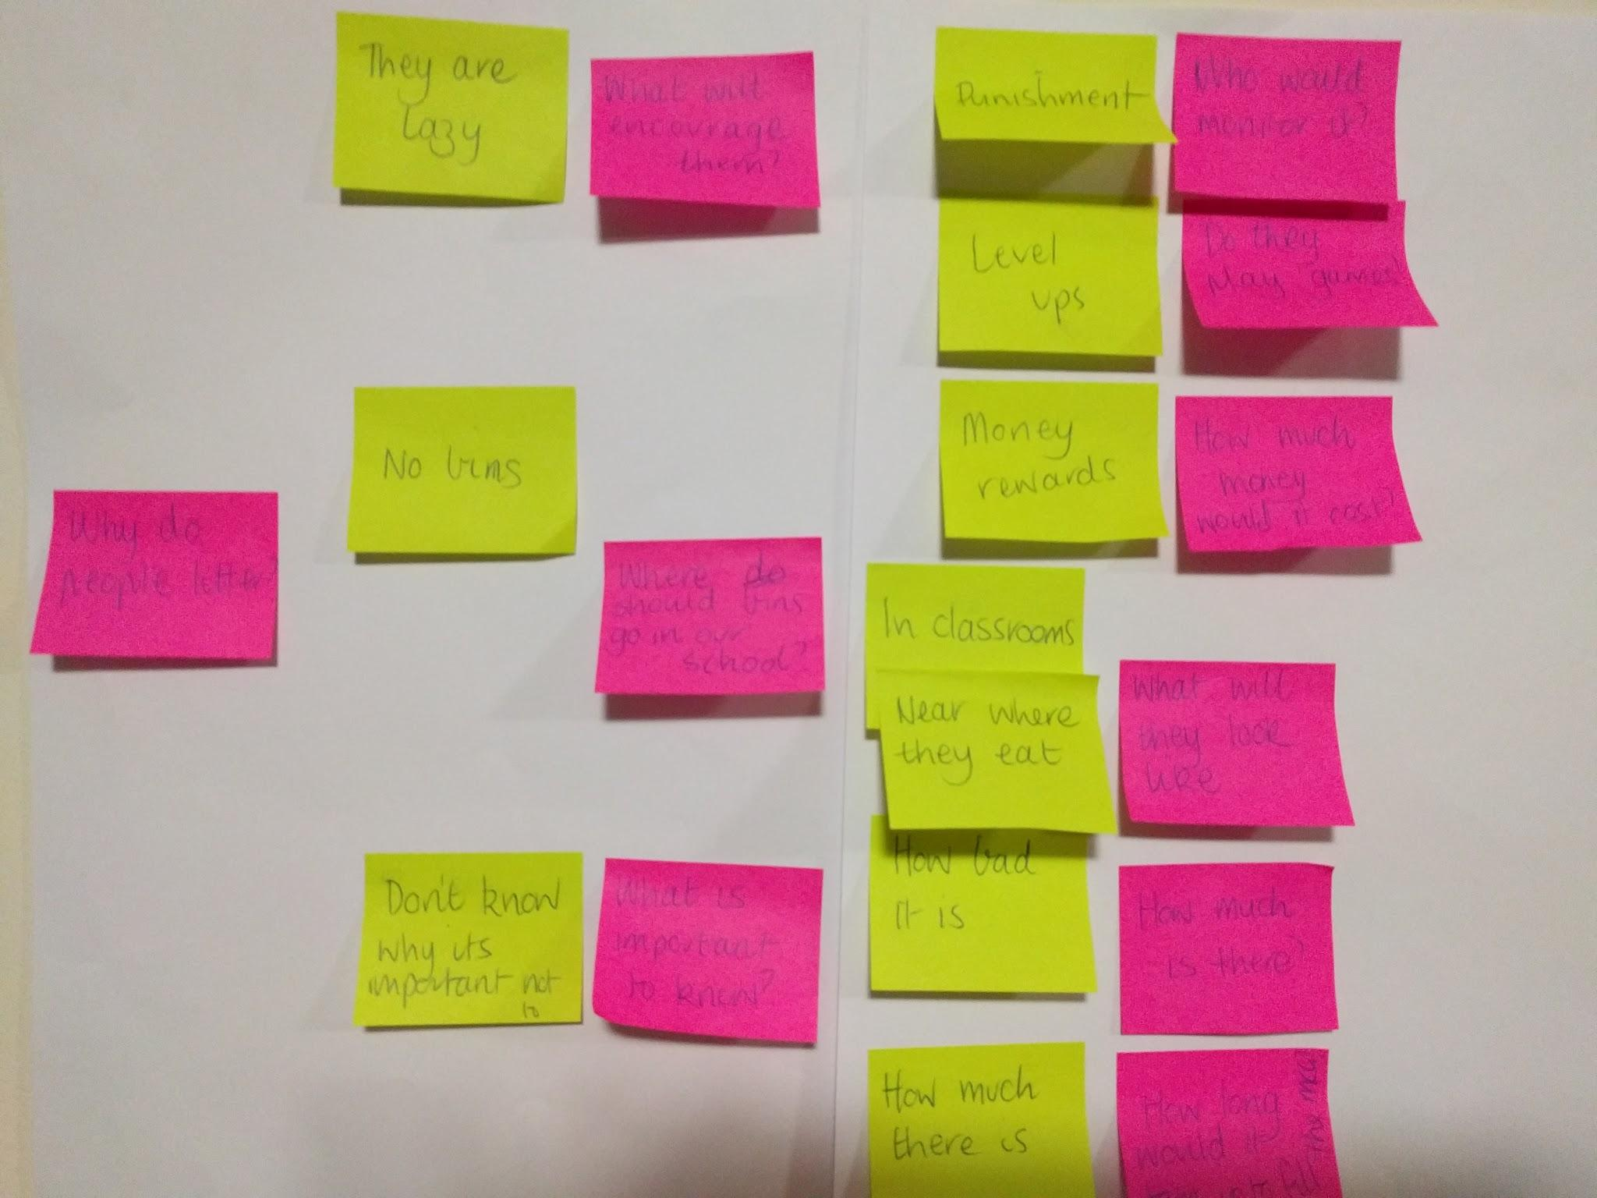

- Now that students know more about the problem it is time to understand the people whose behaviour they are trying to change or influence. For this design brief, the people are the children in the school. Students will need to interview a variety of other students across the school to learn about the decisions they make and how they feel. Students should be encouraged to use their SQUID as inspiration for their interview questions.

The first step is for students to develop the questions they wish to have answered. The questions should be open-ended to elicit as much information as possible. Students should start by brainstorming the different questions they could ask, and grouping similar questions together. The questions should be brief and to the point so that the user doesn’t get confused.

Example questions include:
- Have you ever dropped rubbish before and what were the different reasons for doing this?
- Tell me about the last time you dropped rubbish.
- Why do you think people drop rubbish?
- What do you know about where litter goes?
- What do you know about the impact of litter?
- What do you notice about rubbish in the school?
- What frustrates you about rubbish in the school?

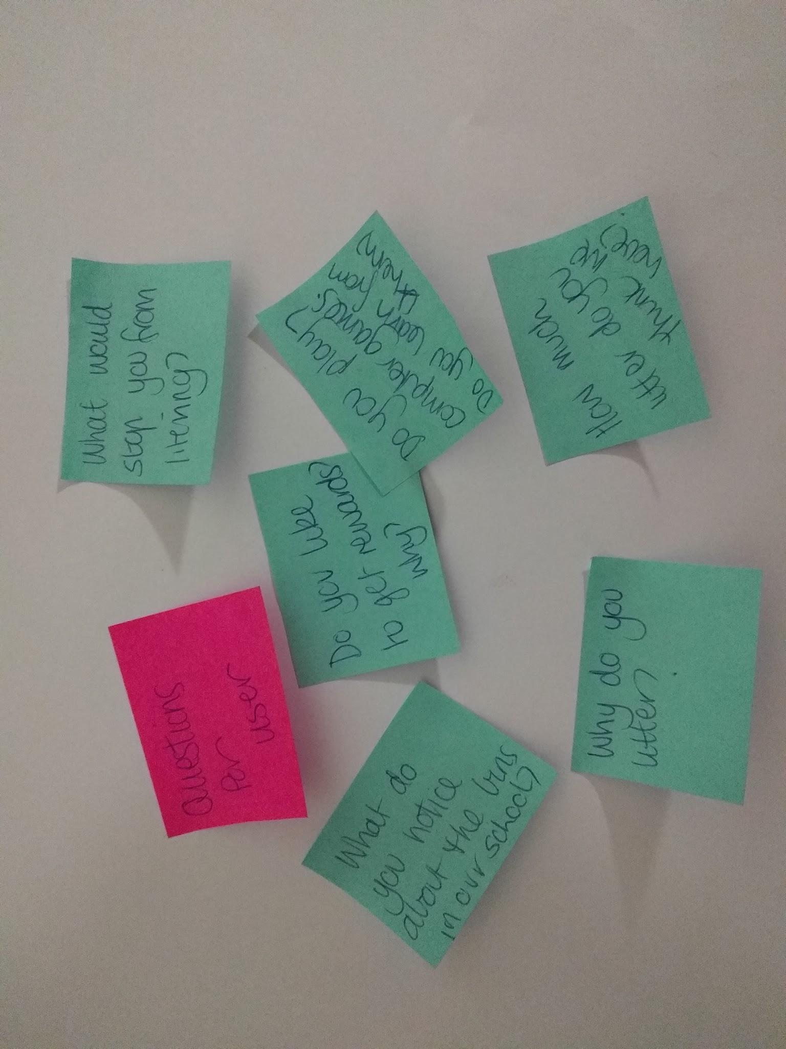

The interviews should be conducted in pairs; one student asks the question and the other takes notes.

The following tips may help students to conduct the interview:
- Set up the interview so the person being interviewed feels comfortable and is more likely to be honest.
- Explain why you are doing the interview and what you are trying to find out.
- Listen carefully to the answers and observe the person’s body language.
- Don’t answer your own questions.
- Prompt the person for more information when needed.
- Give them time to answer. Sometimes silence is a good opportunity to think.

Give students time to identify the key messages from the answers.

Learning demo
Prepare a time for students to share their learning. This can be set up as a pitch to show others that there is actually a problem with rubbish and what we know about users.
Give each pair two minutes to share the most important findings from their empathising.
Students can frame the pitch using the following structure:
- what they found out about the problem (this could include visual representation of the data)
- what insights (surprises, frustrations, motivations) they realised about the problem (taking the information from the SQUID activity)
- what they learned about the users (taking information from the interview results).

Learning reflection
After the presentations, facilitate a discussion recapping the understandings.

- Understanding the user helps us to make decisions on their behalf.
- By listening to and observing the user we can learn about them.
- Good listening will allow us to learn more about users.
- Sometimes people speak through their body language.
- There are many different perspectives; understanding these can help solve problems.

Ask students the following questions to guide reflection:
- What was the most important thing to find out about the user?
- Did you gain any insights into the user (what were the surprises or interesting things you learnt)?
- What did you learn about the problem that you didn’t know before?
- Why is empathising such an important part of the design thinking process?
- What might happen to your design if you don’t have a clear understanding of the user or problem?
- How will this understanding of the user help you to solve the problem?

Assessment
Throughout the activities and during the demo and reflection, observe the students’ understanding of the empathising stage of design thinking.
Look for students’ understanding by asking yourself the following questions:
- Did they take notes about what they were observing?
- Did they listen carefully to the users?
- Did they observe body language and make inferences from this?
- Did they seek information from a number of places to understand the different perspectives of users?
- Did they synthesise all they had learnt about the user and problem into a few clear statements?
- Could they give an overview of the users or the problem in a clear and focused manner?
- Could they explain how their thinking changed throughout the empathising process?
- Could they describe the user with insights they identified?
- Did they use what they learnt from the SQUID in the interview questions?

Design thinking rubric

 | Empathise | Define | Ideation | Prototype | Evaluate
Extending | Has sought more than one way to connect with users and shows insight and depth when talking about users’ needs. | The design brief is clearly re-framed around a user and the needs of the user are included in the point of view statement. | A large number of ideas that show variety in thinking. The student chooses a few diverse ideas to further develop. They work as a team to build on each other’s ideas. | The prototype demonstrates how it is a solution for users. The iterations as well as challenges are described in reference to any testing completed. | The designer describes in detail all iterations and what was learnt from each user testing as well as how effective their final product is in relation to the needs of the user.
Proficient | Empathy is expressed by explaining what needs the users have including user essentials. They discuss what surprised them about their users. | The point of view statement is revised and described with the user in mind. | A large number of ideas ranging from sensible and easy to create to those that are creative and difficult to create. The student chooses a few ideas to further develop. | The prototype shows how it has been improved on and how it reflects any user testing. | The designer can describe the steps taken as well as how effective their final product is in relation to the needs of the user.
Developing | Describes the user but relies on prior knowledge rather than new information. | Mentions the user but the design brief remains unchanged. | Limited range of ideas that are similar in nature. | The prototype shows some iteration and testing as it is developed. | The designer can describe the steps taken to complete their design.

<H2>Resources
An introduction to design thinking: Process guide

