DT + English

Title: Three little pigs
Summary Text: Retell the story of the Three Little pigs using a light sensing robot such as Ozobot.
Year Level: F–2
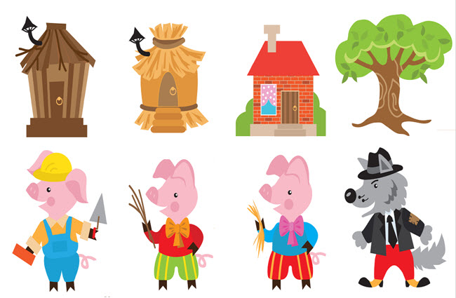

3 Little Pigs images: Lanaart/Shutterstock.com

Suggested steps
- Students read or listen to the story the Three little pigs and participate in a classroom discussion to consider plot development.
- Support students to become familiar with the significant events within the story, such as beginning (orientation), problem (complication) and solution (resolution).
- Students draw pictures of the main events that can be used to retell the story. Alternatively provide the images supplied. [Link to Three little pig images at end of this manuscript]
- Introduce a robotic device that uses a light sensor to follow commands. In this example we are using Ozobot. Allow time for students to explore the Ozocodes. With younger learners you may want to organise Year 6 buddies to support with this part of the lesson.
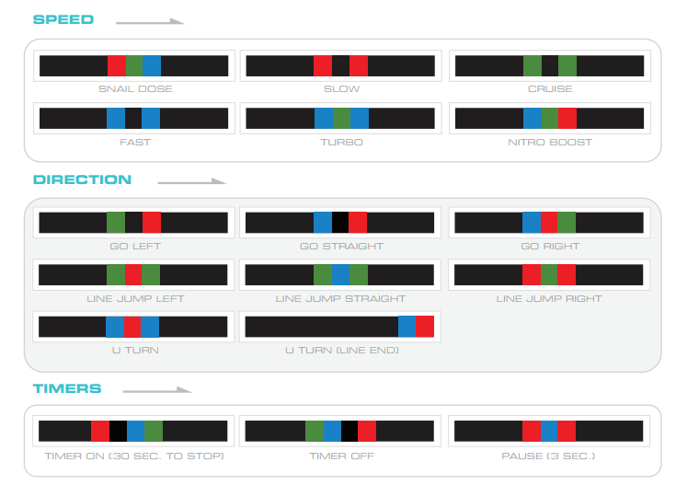
OzoCodes - Ozobot

- Depending on your learners, you could do one of the following:
- Provide students with a large sheet of paper to create their program using the Ozocode stickers available for purchase. Use their own images or the images supplied to sequence the story and create instructions for Ozobot to follow.
- Ask students to create their own colour codes using chisel-tipped felt markers. This will require more testing and debugging to see what the colour combinations do.
- Map out the story and test to see if their instructions (commands made up of a series of colours) work. Students retell the story as Ozobot moves which can be recorded.
- Share the different ways that students have programed their robot to help retell the story.

Discussion

Literacy focus
- If we put the events in the wrong order, what happens? (The story would not make sense.)
- Why do we leave out things that are not important ('irrelevant details') when we retell a story? (They distract us from the main story.)
- What words can we find that are used to link events? (Examples: then, after, soon, later.)
Digital Technology focus
- How can you make a robot do what you want?
- How does Ozobot know what to do?

Why is this relevant?
Abstraction
One of the key concepts within the Digital Technologies curriculum is Abstraction. Abstraction involves hiding details of an idea, problem or solution that are not relevant, to focus on a manageable number of aspects. Abstraction is a natural part of communication: people rarely communicate every detail, because many details are not relevant in a given context.
The idea of abstraction can be acquired from an early age. For example, when students are asked how to make toast for breakfast, they do not mention all of the steps explicitly if they assume that the listener is an intelligent implementer of the abstract instructions.
Central to managing the complexity of information systems is the ability to ‘temporarily ignore’ the internal details of the subcomponents of larger specifications, algorithms, systems or interactions. In digital systems, everything must be broken down into simple instructions.
Programming a robot
A robot needs instructions or commands to know what to do. Ozobot robots have a visual sensor which it uses to gather information about its surroundings. It can follow visual commands which are made up of a series of colors.
Students can create or select visual commands to instruct the robot to complete a task.

Resources

This printable reference chart contains some of the color sequences that constitute the building blocks of Ozobot’s language.

Tips on how to use Ozobot

Printable tracks

Sticker codes for purchase.

Assessment

Peer assessment
Students retell their story.
- Are the events arranged in the correct sequence?
- Are the most important details included and irrelevant details excluded?
Assess students against the solo taxonomy.

Retell the story of the Three Little pigs using a light sensing robot such as Ozobot.
One | Many | Relate | Extend
Identify & Define | Combine & Perform Serial Skills | Apply  Integrate | Create &  Evaluate
I can identify the characters of the story  I can identify the main events | I can order the main events in the correct sequence | I can explain how the story begins, identify the action that leads to the ‘problem’ and discuss how the story ends. | I can retell the story while the robot I have programmed  moves to the main events of the story
I can identify the ozobot  I can describe the colour codes used to command Ozobot | I can use some of the colour codes to make ozobot move  I can predict how ozobot will move based on the colour code used | I can draw my own colour codes to make Ozobot move  I can make Ozobot perform commands such as move, slow down, speed up, pause and stop | I can create a series of commands using colour codes to control ozobot to achieve a described outcome
 | Computational thinking | Computational thinking | Design thinking

Australian Curriculum Alignment

English
Retell familiar literary texts through performance, use of illustrations and images (ACELT1580)
Construct texts using software including word processing programs (ACELY1654)
Discuss characters and events in a range of literary texts and share personal responses to these texts, making connections with students' own experiences (ACELT1582)
Discuss features of plot, character and setting in different types of literature and explore some features of characters in different texts (ACELT1584)

Technologies – Digital Technologies
Follow, describe and represent a sequence of steps and decisions (algorithms) needed to solve simple problems (ACTDIP004)
Create and organise ideas and information using information systems independently and with others, and share these with known people in safe online environments (ACTDIP006)

ICT Capability
Typically, by the end of Year 2, students:

Collaborate, share and exchange
Use purposefully selected ICT tools safely to share and exchange information with appropriate local audiences

Select and use hardware and software
Identify and safely operate a selected range of appropriate devices, software, functions and commands when operating an ICT system and attempt to solve a problem before seeking help
